ANN JERKINS-HARRIS ACADEMY OF EXCELLENCE

728 Parkside Boulevard, Toledo, Ohio 43607

A monthly newsletter from the Department of Special Services

VOL. 2 Issue 06

WORKING TOGETHER FOR FAMILY SUCCESS JANUARY, 2022

FAMILY MATTERS
EVERY CHILD. EVERY PARENT.
Family Matters is an outreach effort from the
ANN JERKINS-HARRIS Academy of Excellence–
Department of Special Services and its SPED Program. Family Matters will provide parents with information about special education and other resources available to assist them to help their children.

SPED PROGRAM MISSION STATEMENT
The mission of the ANN JERKINS- HARRIS Academy of Excellence SPED Program is to create and maintain an effective learning environment by establishing behavioral supports and the social culture needed for all students in our school to achieve social, emotional, and academic success.

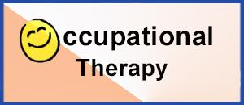
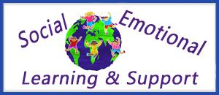
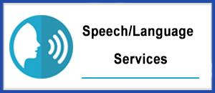

THE DIRECTOR’S CORNER  SPED PROGRAMS AND RELATED SERVICES  Editor—Family Matters Newsletter  Dr. Israel I. Koppisch  iikoppisch@aeetoledo.org  Tel: 419-382-2280 | 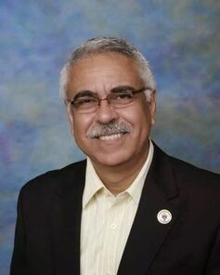
Dear Parents and Friends:

Dear AJHAE family and friends:

Dr. Israel I. Koppisch

DIRECTLY TO YOU…
FROM THE INTERVENTION SPECIALIST
Margaret Hallett

mhallett@aeetoledo.org

Sincerely,

Molly Hallett
Intervention Specialist
.

MY CORNER
MRS. VERNA CHEARS
SPED TEACHER-TUTOR

THE SPEECH THERAPIST CORNER
Mrs. LAUREN NOTESTINE
Speech / Language Therapist

-

THE SCHOOL LEADER’S  MESSAGE  Mrs. Sonya Loggins | MESSAGE  Sincerely,  Mrs. Sonya R. Loggins

ANN JERKINS-HARRIS ACADEMY OF EXCELLENCE
FAMILY MATTERS COMMUNITY OUTREACH PROGRAM
Department of Special Services - SPED Programs and Support Staff

Dr. Israel I. Koppisch  Director, Department of Special Services  SPED Program and Related Services  Editor—Family Matters Community Outreach Newsletter  Margaret Hallett  Intervention Specialist  Verna Chears, Teacher-Tutor  Anita Harris- Teacher-Tutor  Deanna Peoples- Support Staff  Chinnon Jaquay, School Psychologist  Lauren Notestine, Speech and Language Therapist  Johnathan Pitts, Occupational Therapist Supervisor  Katelyn Spiess, Occupational Therapist  Marcus Hanes, Licensed Social Worker / Behavior Specialist  T.A.C.K.L.E. Program Staff- soon to be announced | VISIT OUR NEW WEBSITE  SPED PAGES  www.academyofeducationalexcellence.org

