ANN JERKINS-HARRIS ACADEMY OF EXCELLENCE

728 Parkside Boulevard, Toledo, Ohio 43607

A monthly newsletter from the Department of Special Services

VOL. 2 Issue 02

WORKING TOGETHER FOR FAMILY SUCCESS SEPTEMBER, 2021

FAMILY MATTERS
EVERY CHILD. EVERY PARENT.
Family Matters is an outreach effort from the
ANN JERKINS-HARRIS Academy of Excellence–
Department of Special Services and its SPED Program. Family Matters will provide parents with information about special education and other resources available to assist them to help their children.

SPED PROGRAM MISSION STATEMENT
The mission of the ANN JERKINS- HARRIS Academy of Excellence SPED Program is to create and maintain an effective learning environment by establishing behavioral supports and the social culture needed for all students in our school to achieve social, emotional, and academic success.

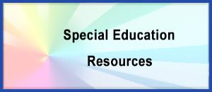
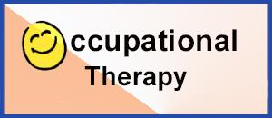
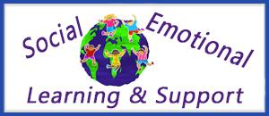
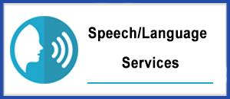
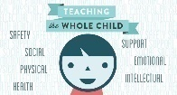

THE DIRECTOR’S CORNER  SPED PROGRAMS AND RELATED SERVICES  Editor—Family Matters Newsletter  Dr. Israel I. Koppisch  iikoppisch@aeetoledo.org  Tel: 419-382-2280 |  | 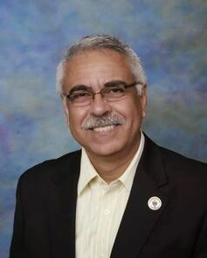
Dear Parents and Friends:

Medicine Safety Basics

www.cdc.gov
For safe medicine use:  - Always check with your doctor if you're unsure whether symptoms need medical treatment.  - Never use leftover medicines. For example, pharmacists will sometimes dispense more liquid medicine than is needed in case some is spilled or measured incorrectly. If you have leftover liquid medicine, throw it out. For medicines taken as needed, keep an eye on the expiration date to make sure you don't give an outdated medicine.  - Never give your child medicines that have been prescribed to someone else, whether it's an adult or child. Even if two people have the same illness, they may need different drugs with different dosages and directions.  - Never give a child a medicine that is meant for adults.  - Check with your doctor or pharmacist before giving two types of medicines with the same ingredients to your child.  - When buying OTC medicines, check the packaging for possible tampering, and don't use any medicine in a cut, torn, or sliced package. Check the expiration date too.  - Work with a local pharmacist so that your family's medicine history is in a central location. Consult your pharmacist if you have questions about any medicine, including information about possible side effects or reactions.  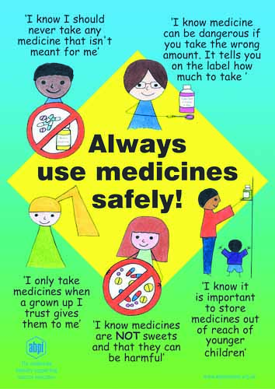 | Giving Medicines to Kids  Double check. First, check to make sure you have the correct prescription. Many prescription and medicine bottles look the same, so make sure your child's name is on the label and it's the medicine that the doctor recommended or prescribed.  Be especially careful when reaching into the medicine cabinet in the middle of the night — it's easy to grab the wrong bottle when you're sleepy.  Read all instructions. Both prescription and OTC medicines usually come with printed inserts about common side effects and further instructions on how to take the medicine. Be sure to read all information carefully before beginning the medicine. The label may instruct you to shake a liquid medicine before using so that the active ingredients are evenly distributed throughout it. Call the doctor or pharmacist if you have any questions.  With or without food? All prescription medicines have labels or instructions about how to take them. For example, "take with food or milk" means the medicine may upset an empty stomach or that food may improve its absorption. In this case, your child should eat a snack or meal right before or after taking the medicine.  Another common instruction on prescription medicines is "take on an empty stomach," in which case your child should take the medicine 1 hour before or 2 hours after a meal because food may prevent the medicine from working properly or may delay or reduce its absorption. Some medicines interact only with certain foods or nutrients, such as dairy products, so be sure to check the label for other instructions.  The right dose. Giving the correct dose is important because most medicines need to be taken in a certain amount and at certain times to be effective. The dose will be written on the prescription label or, on OTC medicines, should be printed on the package insert, product box, or product label.

Measure carefully. You can dispense medicine in a variety of ways. For babies who can't drink from a cup, try a dosing syringe, which lets you dispense the medicine into your baby's mouth, making it less likely to be spit out. Be careful, though — many come with a small cap on the end that can be a choking hazard to young children. Store a medicine syringe in a safe place out of the reach of kids.  Other options for young kids are:  - plastic droppers  - cylindrical dosing spoons, which have a long handle that's easier for children to grab  - if your child can drink easily from a cup without spilling, the small dosage cups that come with many medicines  Never use tableware or a kitchen spoon to measure medicine because these don't provide standard measurements. Instead, get a measuring device designed to deliver accurate medicine doses from your local pharmacy or drugstore.  Some medicine dispensers for infants and toddlers look like pacifiers. With these, you put the medicine in a small measuring cup attached to a pacifier, and then give the pacifier to the baby to suck. Most of the medicine slips past the taste buds, making it go down easily.  Whatever method you use, it's important that your child takes all the medicine each time. If a dose is missed, never give two doses at once to "catch up."  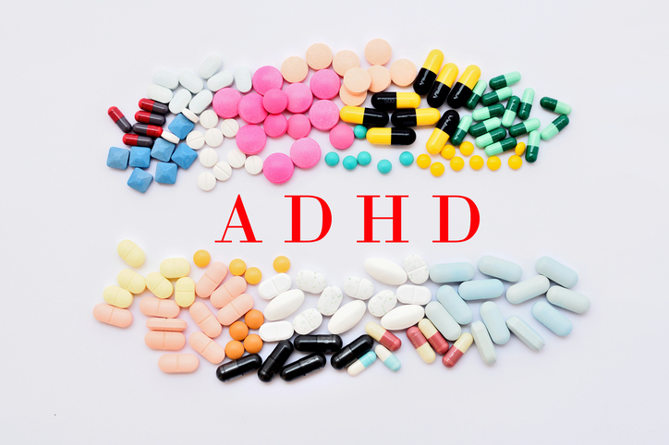 | What if a child must take prescription medication during the school day?  Prescription medication can only be administered in school when it would be detrimental to a child’s health or school attendance not to administer it.  A school can only accept prescribed medicines if they are in-date, labelled, provided in the original container as dispensed by a pharmacist with clear instructions for administration, dosage and storage.  Schools must keep a written record of all medicines administered to individual children, stating the amount of the prescription drug held in the school, and how much was administered, when and by whom. The school should store the medication in a non-portable container but the pupil should know who holds the key to the container.  Appropriate training must be provided to staff expected to administer the medication and only named staff should have access to it, although it should be easily accessible in an emergency. If staff must administer the medication, they should do so in accordance with the prescriber’s instructions.  If appropriate and competent to do so, after consultation with the parents, students are allowed to carry and administer their own medication. They may require an appropriate level of supervision to do so. The pupils must not pass it on to another child, so monitoring arrangements may be necessary. Parents should never be made to feel obliged to attend school to administer the medication to the child themselves.  If a child refuses to take their medication, the school cannot use force. The parents should be informed so that alternative options can be considered.  When no longer required, the prescription medication should be returned to the parent to arrange for safe disposal.

How Can We Safely Dispose of Medicines?
The best way to dispose of unwanted medicines is through a medicine disposal site. The U.S. Drug Enforcement Administration (DEA) periodically hosts National Prescription Drug Take-Back events. Temporary collection sites are set up in communities for safe disposal of prescription drugs. There are also permanent sites in many areas. Visit the DEA website to find a disposal site near you.

If you can't dispose of your medicines at a disposal site, keep these suggestions in mind:
- When disposing of medicines, make sure they stay out of the reach of children and don't contaminate the environment.
- Check the package for specific instructions on how to dispose of the medicine. Do not dispose of medicines in the toilet unless the package says it's OK.
- Break down tablets or capsules and mix them with another substance, like used coffee grounds or kitty litter. That way, kids and pets won't try to get to the medicine. Next, put the mixture in a bag or container and seal it closed, then toss it into a garbage can.
- Return the medicine to a local pharmacy. Many pharmacies take back expired pharmaceuticals. Each pharmacy has a different policy, so contact yours to see if it will accept them.
- Local household hazardous-waste collection facilities often take expired medicines. These are the places where antifreeze, oil, and used batteries are taken for proper disposal. Each facility has a different policy about unused medicine, so call first.
- Take special care to dispose of unused pain medicines promptly to prevent the potential for theft/abuse.
- Put needles in the trash in a thick plastic container (like a laundry detergent container) or a metal can (like a coffee can) where the lid has been carefully secured.
Reference: www.cdc.gov

Aspirin Alert!  Never give aspirin to kids, especially during viral illnesses. Using aspirin during an illness caused by a virus (such as the flu, chickenpox, or an upper respiratory infection) can cause Reye syndrome. This potentially life-threatening disease can cause nausea, vomiting, and extreme tiredness that progresses to a coma.  Some OTC medicines (including some that treat headache and nausea) contain aspirin. So always read labels and check with your doctor or pharmacist before using them. Also, some aspirin-containing medicines use words other than aspirin, such as salicylate or acetylsalicylate. Avoid those too.  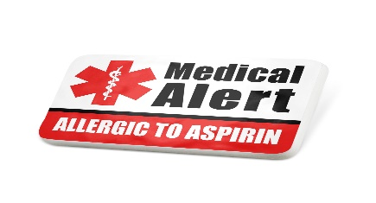 | Can the child go to any teacher to get help with their medical needs?  If a child approaches any member of school staff (including supply and temporary staff) requiring medical support, that member of staff should know what to do and respond accordingly. However, administering medicines is not part of a teacher’s professional duties. Unless school staff have received sufficient and suitable training, they cannot take on responsibility to support children with medical conditions. This is the responsibility of the school nursing services. A school nurse’s main responsibility, in supporting schools to look after children with medical conditions, is to make sure enough staff are competently trained to look after a child and that the child is being supported properly. Nurses will understand their role by reference to a comprehensive school policy.  If the child approaches a teacher with a medical need that can be self-managed, for example having a drink or snack or taking toilet or other breaks to manage their medical condition effectively, the teacher should co-operate with the child in allowing them to do so.

What About Side Effects?
After giving your child a dose of medicine, be on the lookout for side effects or allergic reactions. The pharmacist or product packaging may warn you about specific side effects, such as drowsiness or hyperactivity.
If your child has side effects such as a rash, hives, vomiting, or diarrhea, contact your doctor or pharmacist. Penicillin and other antibiotics are among the most common prescription drugs to cause an allergic reaction.
If your child develops wheezing, has trouble breathing, or difficulty swallowing after taking a medicine, seek emergency help by calling 911 or going to the emergency department immediately. These could be symptoms of a serious allergic reaction that requires emergency care.
Sometimes children have unusual reactions to medicines, such as hyperactivity from diphenhydramine, which usually makes adults feel sleepy. Tell your doctor if this happens.
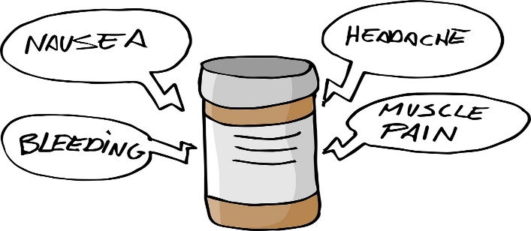

How Should We Store Medicine?

Be as careful about storing medicines as you are about giving the correct dose. Read the medicine's instructions. Some drugs need to be refrigerated, but most should be stored in a cool, dry location away from direct sunlight.
Your bathroom's medicine cabinet is a poor choice for storing most medicines because of the humidity and moisture from the tub or shower. Instead, store medicines in their original containers in a dry, locked location that kids can't reach. Above-counter kitchen cabinets are great spots if they are away from the stove, sink, and hot appliances.
Child-resistant caps can be hard even for adults to open. But protect your kids by re-locking and recapping child-resistant bottles properly. Kids can sometimes open the cap, so it's important to lock away all medicines. If any visitors to your house have medicine in their bags, purses, or coat pockets, make sure they put those out of sight and out of reach.

What Can Medications Do for My Special Needs Child?

by Jack Taulbee, Ed.M., M.A.
One of the most worrisome inquiries I get from parents deals with medication issues. Since I am not a physician or a psychiatrist I cannot answer whether a medication is appropriate for the symptom(s) your child is experiencing, but I can help you to better understand what medications can and cannot do.
It is very important that we understand two things. Medications do not cure nor do they teach. What they do is help to minimize interfering symptoms which so often prevent the child from controlling unwanted behaviors and/or help suppress the neurological “noise” in the child’s mind allowing the child to access much needed instruction. This can help the child both at home and at school.
Both of these improvements create a better environment for communication between child and parent, or teacher. When the child can hear without the emotional and mental smoke screens that neurological disorders produce opportunity for improvement is immediately created and progress is made.
We need to realize that medications can be valuable tools in helping the child succeed, however we must not rely on medications as a miracle cure for all the problems facing the special needs child.
Think of it this way. With know that glasses do not heal a child’s eye problems. They do however help the child focus so they can see the words and begin the learning process. No longer is the child’s disability preventing him from reading and being educated, however, at no time do we fool ourselves into believing that the glasses make the eye problems physically disappear. Instead we see them as a tool that assists the child so they can gain access to printed language.
We should view medications in the same way. They do not cure the neurological disorders nor do they teach the child. Instead they help reduce the mental and emotional interferences in communication that prevent the child from experiencing life as others do. Medications can have a valuable place in a special needs child’s life when they are accepted as a resource for which they were designed and intended.

GETTING HELP

Children with behavioral or emotional disorders are a special group and need special care. Many times children have symptoms that are different from adults with the same disorder. Symptoms may also vary from child to child, and it can be difficult to understand a child's signs and symptoms. Children may have trouble understanding their illness and may not be able to describe how they feel. Sometimes the warning signs a child shows are overlooked. If you are concerned about your child's behavior or emotional health, talk with your child's health care provider about getting help.

There are many different types of help for children with behavioral or emotional disorders. Some examples are:

- Cognitive therapy
- Behavioral therapy
- Occupational and Physical therapy
- School Programs
- Parental and/or Family therapy
- Group therapy
- Medications - sometimes called Medication Therapy

MEDICATIONS

Before making a decision to treat your child with medication, a qualified health care provider should make a thorough assessment of your child and understand his or her needs. You may meet with a medical doctor (Pediatrician, Psychiatrist, Family Practice, etc.) or with a nurse practitioner or a physician assistant. These health care providers may evaluate behavioral or emotional disorders in children, make a diagnosis and prescribe medication. Part of the health care provider's evaluation of your child may include a physical exam and blood tests. Other 4 tests may also be needed to help the health care provider understand your child's problems.

Medications should fit a child’s needs and be part of a plan that includes other therapies. It is also important to remember that medications will manage but may not “cure” behavioral or emotional disorders like an antibiotic can cure strep throat.

Additionally, certain medical conditions and pregnancy require special consideration. Inform the person prescribing your child’s medication(s) of all known or suspected medical conditions including pregnancy.

Deciding on the right medications to use for children can be difficult. Children's brains continue to develop until they are adults. Some medications that are proven to be safe for adults may have unexpected side effects for children. Also, many medications used to treat adults do not have the same effect on children's brains and body chemistry.

DIRECTLY TO YOU…
FROM THE INTERVENTION SPECIALIST
Margaret Hallett

AT THE ANN JERKINS-HARRIS ACADEMY OF EXCELLENCE
WE HAVE EXCEPTIONAL TEACHERS TEACHING EXCEPTIONAL CHILDREN

mhallett@aeetoledo.org

Greeting Families!

This month we are talking about medicine. As parents we weigh the pros and cons for providing our students with medication to help our children. It is easier to accept the need for medicine for our children when there is an infection within their bodies. When it comes to your child’s emotions and behaviors it can be harder to justify the need for the medication.

When your child’s academics are adversely affected due to their lack of impulse control or focus, you might want to send your child to a doctor to see if there is something that can be done to help. The help can be in the form of talk therapy, neurofeedback, or medication. As a school, we have no right to recommend medication since we are not medical professionals. That is a decision between you and your doctor.

If you and your doctor decide to put your child on medication to help slow their impulses down or to increase focus to help improve their academic performance it is helpful to your child to give them medication to help them during school. According to WebMD.org, there are pros and cons for giving your child a medicine break.

The pros are: this can ease the side effects such as loss of weight, loss of appetite, or sleep troubles, it may help boost your child’s growth, it won’t hurt them, it can be a chance to see if the talk therapy or the neurofeedback is working, or it could help your doctor to see if anything is changing with your child’s behavior.

The cons on giving your child a medicine break are: ADHD symptoms will return or get worse, and when you go to give your child their medicine again it may take a while for the medicine to start working again.

“You should never stop or change your child’s medication without talking to their doctor first.”

Reference:

Smitha M.D.,B. (2020). Should Your Child Take a ADHD Medicine Break?. WebMD.org. https://www.webmd.com/add-adhd/childhood-adhd/adhd-medication-hiatus-benefits

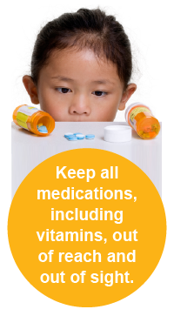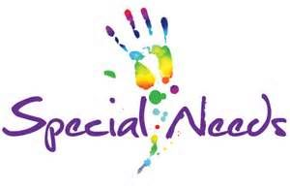

ANN JERKINS-HARRIS ACADEMY OF EXCELLENCE
Department of Special Services - SPED Programs and Support Staff
FAMILY MATTERS COMMUNITY OUTREACH PROGRAM

Dr. Israel I. Koppisch
Director, Department of Special Services
SPED Program and Related Services
Editor—Family Matters Community Outreach Newsletter

Margaret Hallett
Intervention Specialist

Verna Chears, Teacher-Tutor
Anita Harris- Teacher-Tutor
Hannah Jeffers, Paraprofessional
Deanna Peoples- Support Staff

Chinnon Jaquay, School Psychologist
Lauren Notestine, Speech and Language Therapist
Johnathan Pitts, Occupational Therapist Supervisor
Katelyn Spiess, Occupational Therapist
TBD, Licensed Social Worker / Behavior Specialist
Robert Roggenbuck, Social Work Intern

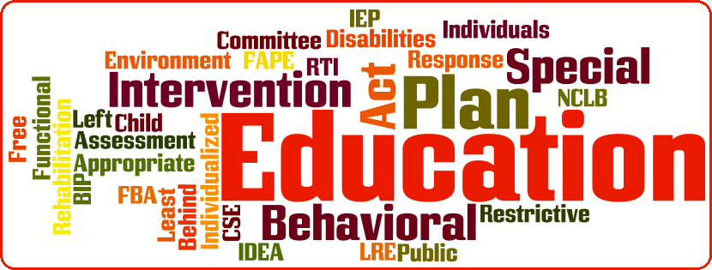

VISIT OUR NEW WEBSITE
SPED PAGES

www.academyofeducationalexcellence.org

AT AJHAE SPECIAL SERVICES DEPARTMENT:
WE WANT TO MAKE THE DIFFERENCE TO ALL OF OUR CHILDREN
Check us on our new website: www.academyofeducationalexcellence.org

As you explore our web pages, you will see that the Special Services Department at AJAAE involves many areas and student services. Our caring staff is dedicated to assisting all students achieve their highest potential.
We are also here as a resource for our families—referrals, partnerships and problem-solving.
Whether you are a student, parent or family member, we hope you will find many resources available to you useful.

