INCLUSIVE LEARNING ENVIRONMENT
728 Parkside Boulevard, Toledo, OHIO 43607
K-6th grade
This institution is an Equal Opportunity Provider
PHONE:
419/ 382-2280
ENROLLMENT APPLICATION
2022-2023
Admission’s Office
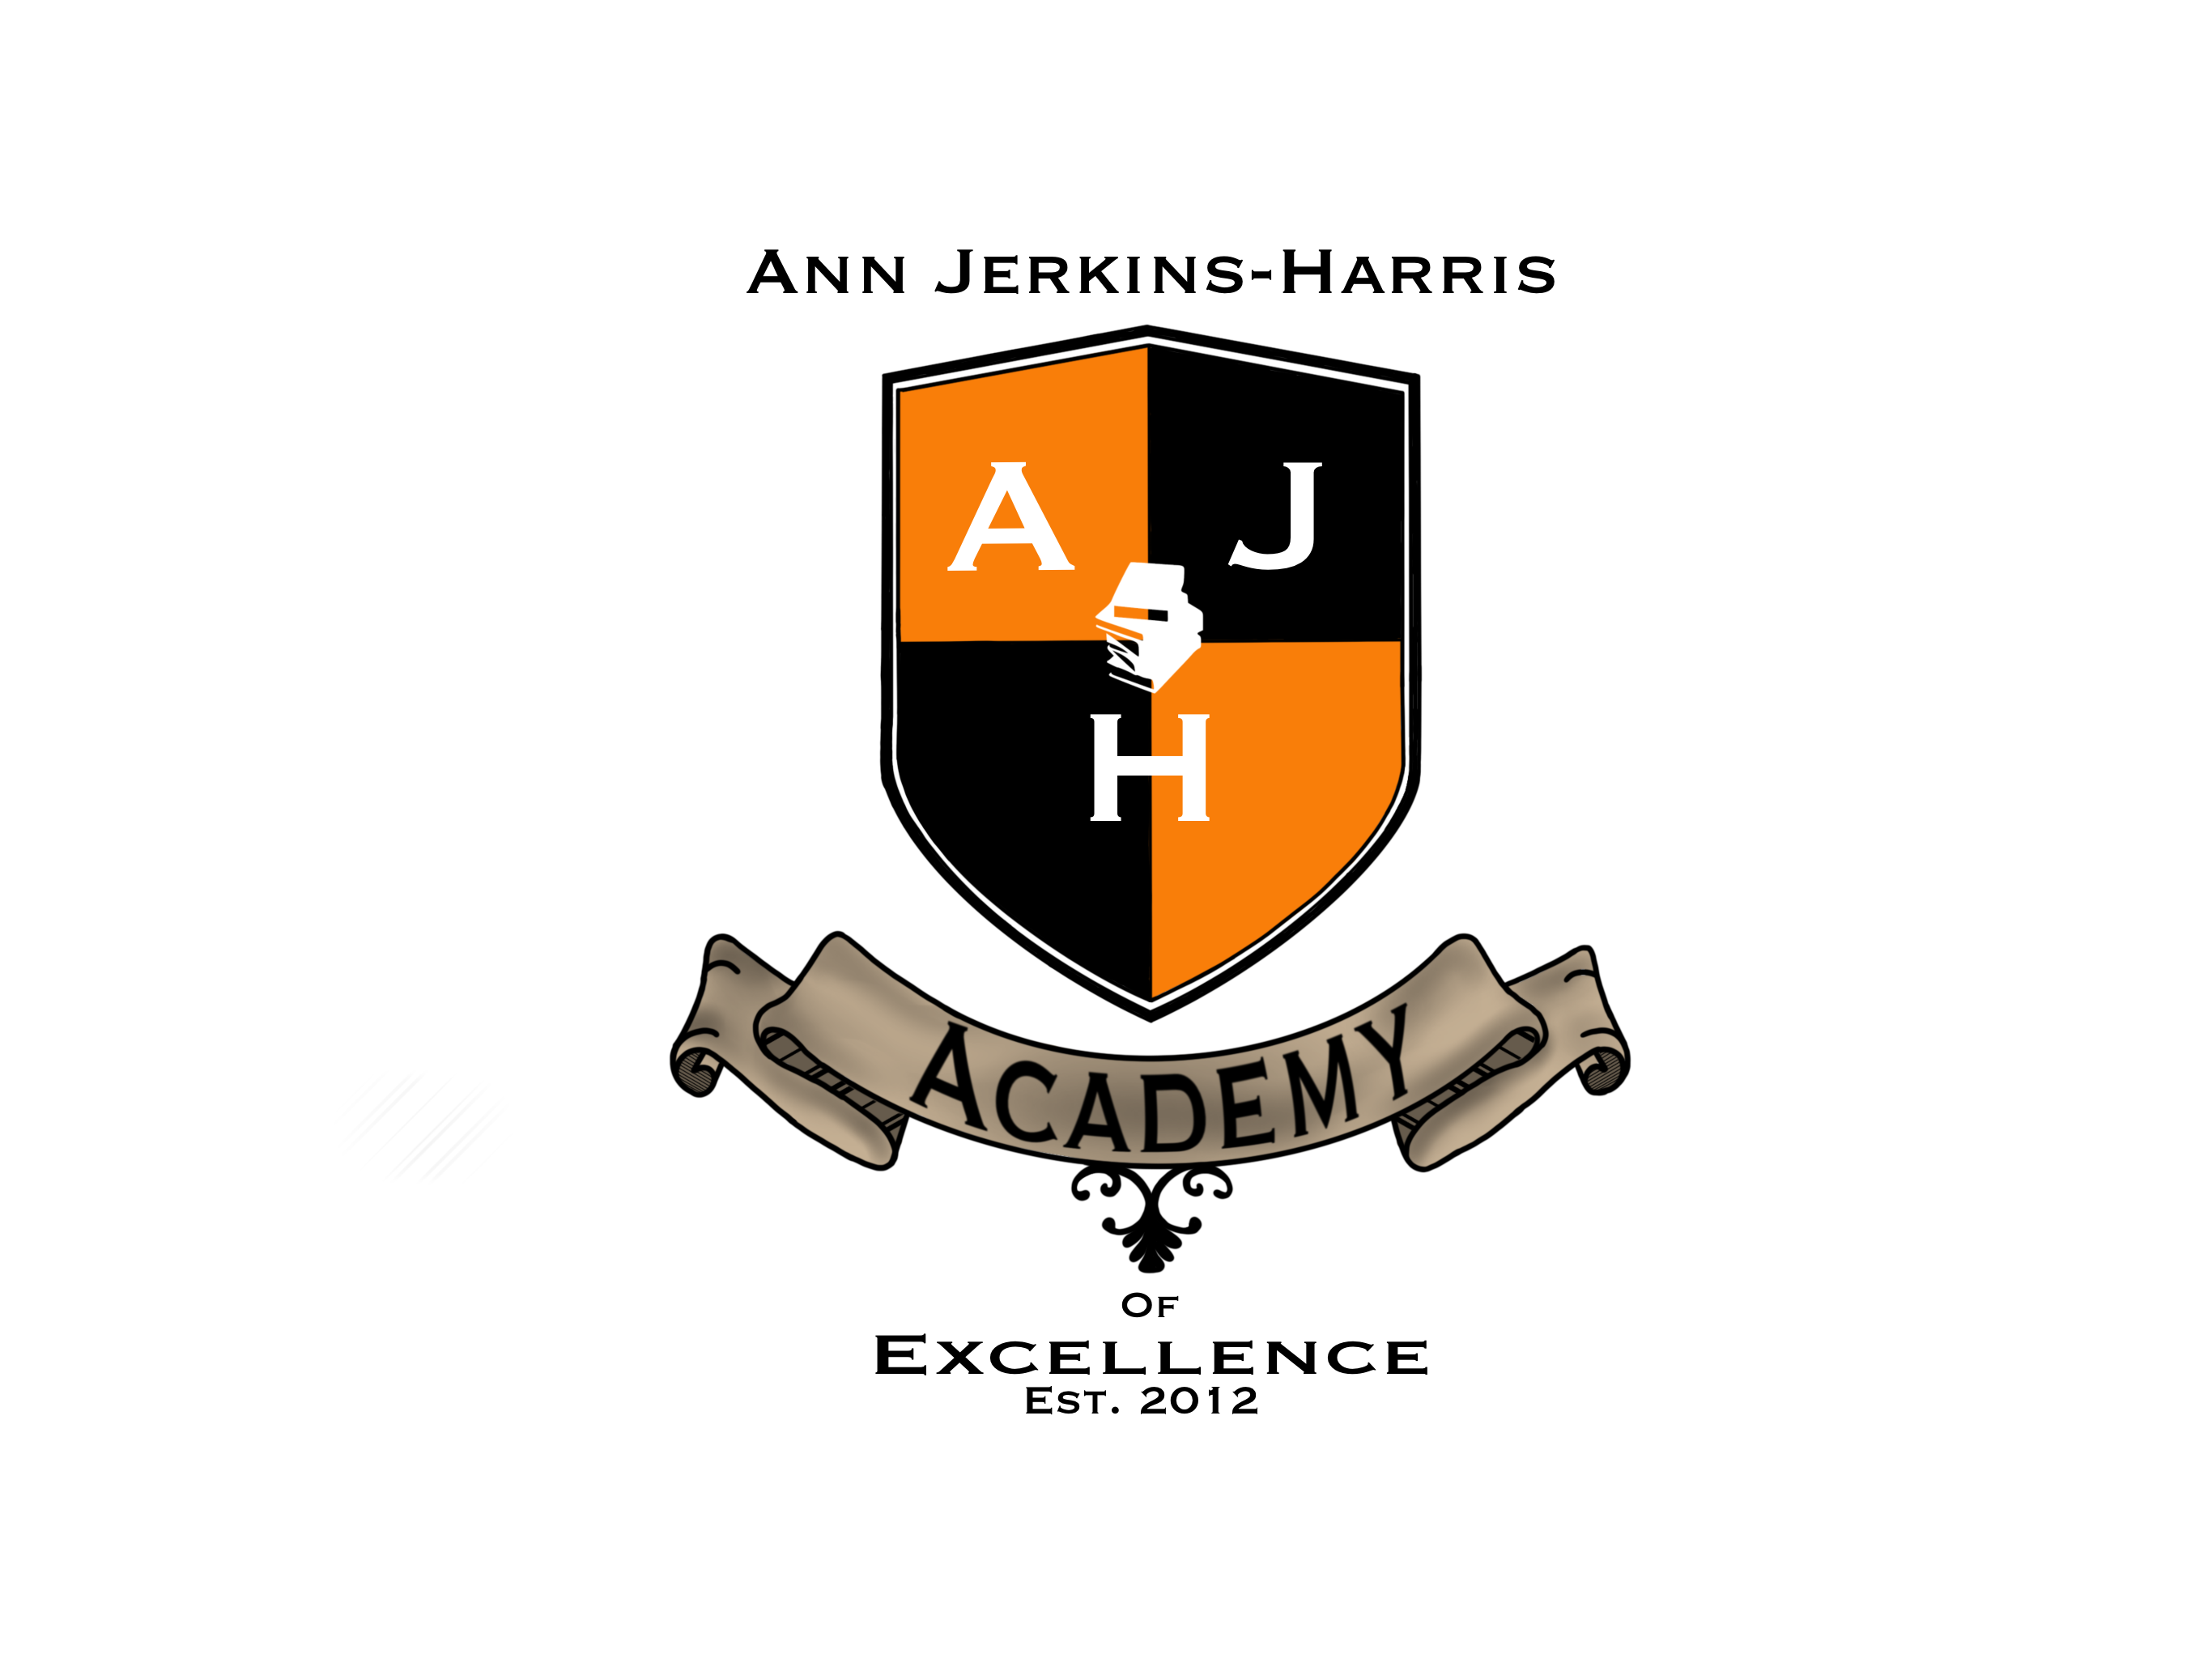

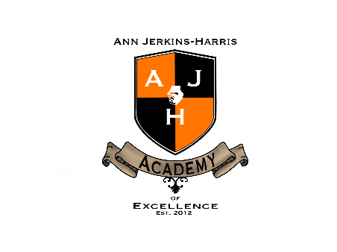
Empowering Students to Become Leaders in a Changing World

ENROLLMENT APPLICATION 2022-2023

Welcome Parents and Students:

For this school year we have limited spaces available on our different grades. If interested in enrolling your child at AJHAE, please complete and return this enrollment packet to guarantee your child a spot for this upcoming school year. Below you will see a checklist of documents needed in order to successfully complete the enrollment process. A packet must be completed for EACH student that will be enrolling. If you have any questions or need assistance completing the form, please do not hesitate contacting us for assistance.

Please submit the following documents with enrollment packet:
Copy of Birth Certificate
Copy of the Immunization Records
Proof of Residency (utility bill, tax records, lease, deed)
Custody Docs (if applicable)
Please note:
- Updated documentation will be requested if you move to a new address.
- Keep the school updated on current information: Phone numbers, emergency contacts, pick up authorization changes etc…
- Student entering Kindergarten must turn 5 years of age NO LATER THAN September 30th.
- ALL candidates will be assessed before being admitted.

VERY IMPORTANT INFORMATION—PLEASE READ

By enrolling your child and signing this document you are agreeing to play a vital role in your child’s education by any means necessary. You are required to attend a parent orientation and previous school records MUST BE received before your child is officially enrolled at our school. Once enrolled, you are required to drop off and pick up your child on time (except if he/she will be using our bus transportation system), attend parent-teacher’s conferences, return forms in a timely manner, notify of any changes in your address or contact list within 5 business days, volunteer a minimum of 1 hour a month and familiarize and follow all school policies and procedures in the Parent/Student Handbook, specifically those procedures related to attendance, discipline, dress-code and personal conduct. The ANN JERKINS-HARRIS ACADEMY OF EXCELLENCE provides an inclusive learning environment school.

Parent/Guardian acknowledges to have read information in this enrollment packet: (Initials)________________________

ENROLLMENT APPLICATION

Section 1: CHILD’S PERSONAL INFORMATION GRADE 2022-2023: __________

FIRST DAY IN SEAT: GRADE/HR: PREVIOUS SCHOOL:

NAME |  | LAST NAME
DATE OF BIRTH |  | PLACE OF BIRTH
NATIONALITY |  | MALE |  |  | FEMALE
ADDRESS
PARENT’S TELEPHONE NUMBERS | HOME | MOBILE |  |  | OFFICE
NAME AND GRADES OF ANY OTHER SIBLING ATTENDING AJHAE: | NAME |  | GRADE

SECTION 2: ACADEMIC DETAILS .

NAME OF SCHOOL(s) ATTENDED  (ADDRESS) | GRADE ATTENDED | FROM | TO

SECTION 3: LEGAL PARENT / GUARDIAN / CAREGIVER DATA

Father’s Name |  | Mother’s  Name
Occupation |  | Occupation
Work Place |  | Work Place
Office Address |  | Office Address
Work Phone |  | Work Phone
Email |  | Email

Guardian’s Name |  | Guardian’s  Name
Occupation |  | Occupation
Work Place |  | Work Place
Office Address |  | Office Address
Work Phone |  | Work Phone
Email |  | Email

SECTION 4: PERSONALITY AND HEALTH INFORMATION .

Provide details of any special aspects of your child’s personality
Provide information of any health problems requiring special attention
(medical certification may be required)

Does the child has an IEP? | ( ) Yes Expiration Date: ____________ ( ) No

CHECK CONDITION(S) YOUR CHILD HAS:

- ADD/ADHD  - ALLERGIES: _______________________  - ASTHMA  - CEREBRAL PALSY  - HEARING AID  - HEART PROBLEMS | - CYSTIC FIBROSIS  - DIABETES  - DOWN’S SYNDROME  - EPILEPSY/SEIZURES  - LEUKEMIA/ CANCER  - MIGRANE HEADACHES  - NEUROMUSCULAR DISEASE  - MUSCULAR DYSTROPHY | - HEMOPHILIA/BLEEDING DISORDER  - ORTHOPEDI DISABILITY  - PSYCHIATRIC DISORDER  - RENAL/KIDNEY DISEASE  - ULCERS/ GASTRIC REFLUX  - OTHER _______________________________
Provide information of any medications child have to take on a daily basis

OTHER HEALTH PROBLEM/ DISORDER/ DISABILITY

IS EXERCISE / PHYSICAL EDUCATION LIMITED BY PHYSICIAN |  | ( ) YES* ( ) NO  *Physician written authorization is required

SECTION 5: EMERGENCY CONTACT INFORMATION AND CONSENT
In the event reasonable attempts to contact parent(s) /guardian listed on the enrollment form are unsuccessful, I hereby consent for (1) the administration of any treatment deemed necessary by above-named doctor, or, in the event, the designated preferred practitioner is not available, by another licensed physician or dentist and (2) the transfer of the child to any hospital reasonably accessible. This authorization does not cover major surgery unless the medical opinions of two other licensed physicians or dentist, concurring in the necessity for such surgery, are obtained prior to the performance of such surgery.

DOCTOR |  | DENTIST
Address |  | Address
Insurance Provider |  | Insurance Provider
Policy Number |  | Policy Number
Phone Number |  | Phone Number
Hospital |  | Hospital
Phone Number |  | Phone Number

GRANT CONSENT  ( ) | I hereby grant consent for emergency medical treatment of my child. In the event of illness or injury requiring emergency treatment– and I cannot be contacted--, I wish the school authorities to take the following action(s): | REFUSAL TO CONSENT  ( ) | I hereby DO NOT GIVE MY CONSENT FOR EMERGENCY MEDICAL TREATMENT OF MY CHILD. In the event of illness or injury requiring emergency treatment, I wish the school authorities to take the following action(s):

Parent Signature: ___________________________________ Date: __________________________

SECTION 6: PERSON(S) PERMISSIBLE TO PICK UP CHILD :
the please contact the individual(s) listed below: (Must be different from parent/guardian)

Name |  | Name
Relationship to student |  | Relationship to student
Occupation |  | Occupation
Work Place |  | Work Place
Office Address |  | Office Address
Work Phone |  | Work Phone
Email |  | Email

SECTION 7: TRANSPORTATION:

Bus____ (home stops may not always be available-please do not request home stops)

Car_____ Other:______________________

SECTION 8: ETHNIC CODE ( If a student is multi-racial, more than one group should be selected)
WHITE | BLACK | HISPANIC | ASIAN | AMERICAN INDIAN | PACIFIC ISLANDER

NATIVE LANGUAGE:

Is English the Student’s Native Language? YES NO

If NO, please identify the students native language: _________________________________________

Please read the cirumstances listed below that apply, then check yes or no.

- Was not born in the United States and his/her native language is not English ? YES NO

- Resides in a home in which a language other than Englilsh is used for communication YES NO

- Resides in a home in which a language other than English has a significant impact on his/her level of level of understanding of the English language YES NO

SECTION 9: MIGRANT OR HOMELESS STATUS
Is this student, this student’s parents, guardian or spouse a migratory worker? Yes No

Does this student have a permanent, regular, and adequate residence? Yes No

SECTION 10: SCHOOL POLICIES

DRESS CODE: At AJHAE we believe that our Dress Code Policy supports a positive learning environment and we expect all our students to:

- Appear clean, neat and well-groomed EACH DAY.
- Arrive and leave school in dress code attire.
- Have shirts tucked-in and completely buttoned at ALL-TIMES.
- Belts must be worn
- No pants below the waist

The ANN JERKINS HARRIS ACADEMY OF EXCELLENCE dress code attire consists of:

- Navy Blue/Khaki pants, Navy Blue/Khaki skirts or jumpers, or navy blue shorts/khaki in the Summer (not more than an inch above the knee).
- White or light blue shirts or blouse
- Plain black school shoes
- NO SWEATSHIRTS OR HOODIES ALLOWED

Dress Code Infraction Enforcement:

Students violating the dress code policy will receive a Dress Code Infraction Form. This form must be returned to school the next day, signed by a parent/guadian. After the first violation, students may be sent home for a change of clothing. The parent or guardian may be required to pick-up the child to allow the student to comply with the dress code policy.

VISITOR POLICY

Visitors are welcome at all times. For the safety of our students and staff, visitors must first report to the office and receive a Visitor’s Badge. Previous arrangements must have been made with specific teacher in order to come-in to observe your child’s classroom. An office clerk will escort you to the designated area. When visiting the school with the intent to speak with a teacher, you must make an appointment first so that the teacher can set aside proper time to focus on your conversation. Teacher’s are NOT authorized to unattend their class in order to receive a parent during teaching-learning period. People interested in volunteering on a regular basis—must obtain a background check.

STUDENT PICK-UP

Parent/guardian or authorized person to pick-up a student MUST check-in at the office upon arrival and be at least 18 years old. We will send for the student to be dismissed. We reserve the right to request an identification (drivers license).

STUDENT LATE ARRIVAL

Students arriving to school tardy must be accompanied by an adult and signed in at the office to receive a tardy slip.

NON-DISCRIMINATION POLICY:

The ANN JERKINS-HARRIS ACADEMY OF EXCELLENCE admits students of any race, color, national and ethnic origin and does not discriminate based on race, color, national origin, disability, age or sex in administration of its educational policies, admissions policies, lunch or bus transportaiton programs, athletic, musical and other school administered programs. This institution is an equal opportunity provider.

HOMESCHOOLER NOTICE:

AJHAE is a community school established under Chapter 3314 of the Revised Code. The School is a public school and students enrolled in and attending the school are required to take the achievement tests and other examinations prescribed by the laws of the state of Ohio. In addition, there may be other requirements for students at the school that are prescribed by law. Students who have been excused from the compulsory attendance law for the purpose of home education as defined by the administrative code shall no longer be excused for that purpose upon their enrollment in a community school. Please contact school administrators or the Ohio Department of Education for more information.

ATTENDANCE POLICY

The educational program offered at the ANN JERKINS-HARRIS ACADEMY OF EXCELLENCE is predicated upon the presence of the student and requires continuity of instruction and classroom participation. The State of Ohio has established standards for students attendane to schools. Attendance shall be required for all students enrolled in the school during the days and hours that the School is in session or during the attendance sessions to which the student has been assigned. In accordance with statute, the School Leader shall require, from the parent or guardian of each student who has been absent from School or from class for any reason, A WRITTEN STATEMENT for such absence.

A parent(s) or guardian(s) of school aged children shall be required to abide by compulsory education laws.

School attendance violations are subject to court prosecuion. When any student of compulsory school age is absent without legitimate excuse, thay may be classified as habitually or chronically truant. The School Leader and/or designee may inform the student and the student’s parent(s) or guardian(s) of the truancy record and the School’s intent to notify the Judge of Juvenile Court of the student’s excessive truancy.

According to the Ohio Law, any student who is absent more than five (5) consecutive days, seven (7) or more days in a month or twelve (12) or more days in a school year is considered habitual truant. Parents of children that are absent or tardy may be required to participate in a parent education program provided by the school. Any parent who does not complete the program is to be reported to law enforcement authorities for neglect of Parent Education, a fourth class misdemeanor if found guilty, with a fine up to $250.00 and imprisonment of up to 30 days.

ACKNOWLEDGEMENT OF SCHOOL POLICIES

My signature below indicates that I have read and received a copy of the school policies. I understand the consequences that are associated with not complying with the school policy on Dress Code, visiting the school and student pick-up/drop off. I fully understand the Attendance Policy and the potential consequences of not sending my child to school. I will do my very best to make sure my child is at school on-time every day ready to learn.

_______________________________ _________________________ ________________
Parent/Guardian full name (please print) Signature Date

AUTHORIZATION FOR MEDIA INTERVIEWS AND PHOTO RELEASE

From time to time outside agencies (local radio or television stations, newspapers or community/state agencies) highlight exemplary programs in our area. This often involves videotaping or taking pictures of students in the classroom setting and/or asking students for their opinions or questions about their educational experiences. While reading that the public has a right and a responsibility for access to information about the activities in our schools, the ANN JERKINS-HARRIS ACADEMY OF EXCELLENCE is very selective in granting such access to the classroom. Nevertheless, AJHAE is a Leader in Me School and periodically receives visits from LIM Franklin Covey Educational Organization and/or consultants from our educational sponsor organization: North Central Ohio ESC. At AJHAE we would normally allow representatives of these two organizations to visit our classrooms and talk to our staff members and students.

By signing below I give permission for my child to participate in school approved interviews/photographs and/or video tapings.

_____________________________________ _______________________________________ _________________
Parent/Guardian full name (please print) Signature Date

By signing below I DO NOT give permission for my child to participate in school approved interviews/photographs and/or video tapings.

_____________________________________ _______________________________________ _________________
Parent/Guardian full name (please print) Signature Date

SECTION 10: DECLARATION .

I confirm that, to the best of my knowledge, the information provided on this form is correct. I have understood and agree to abide by all school rules and regulations including school discipline, inter-school/city transfers, bus and food services regulations.

I also acknowledge that while the school does its best to ensure the safety of each child’s life, health and property, the school cannot be held responsible for any damages to these.

I commit to support my child teacher(s) and to follow-up on his/her academic achievement on a regular basis. I commit to attend to the Parent-Teacher Conferences scheduled by the school.

( ) I authorize ( ) I do NOT authorize my child to participate in school planned fieldtrips. School will provide information to parent’s ahead of time in order to offer general information about our educational activities.

( ) I authorize ( ) I do NOT authorize AJHAE to take photos and/or videos in which my child can be depicted. I understand that school may use these photos or videos for marketing purposes and/or to inform parents about activities being held at school (through social media or school newsletters).

I understand that as a parent/guardian I should support my child’s academic performance. I commit to support teachers and follow-up on a daily basis my child’s school homework in order for him to be able to comply with school’s academic expectations.

_________________________________________________ _____________________________________
Signature of Parent/Guardian Date

