FAMILY MATTERS

ACADEMY OF EDUCATIONAL EXCELLENCE 728 Parkside Boulevard, Toledo, Ohio 43607

A monthly newsletter from the Department of Special Services

VOL. 1 Issue 1 July, 2020
Family Matters is an outreach effort from the Academy of Educational Excellence– Department of Special Services and its Special Education Program. Family Matters will provide parents with information about special education and other resources available to assist them to help their children.
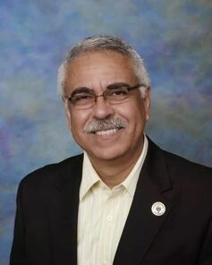  MESSAGE FROM THE DIRECTOR OF SPECIAL SERVICES Dr. Israel I. Koppisch | 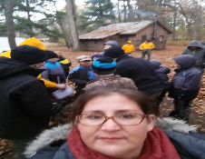  MESSAGE FROM THE INTERVENTION SPECIALIST  Margaret Hallett
Dear Parents  AEE provides a variety of services and placement continuum options for students with learning disabilities. All services and placement decisions are determined by the Individual Education Program (IEP) team which includes parents and school personnel. According to federal guidelines, students are placed in the Least Restrictive Environment in which they can be successful.  If you suspect that your child has a disability, contact our School Principal. You are entitled to a free educational evaluation for your child to determine if special education and/or related services are necessary for your child to receive a Free and Appropriate Public Education (FAPE).  If you are moving to our school and your child is currently on an IEP, please contact the Office of Special Services. We want to assist you and your child in making the transition to our school.  I look forward to serving you and your children at AEE.  Cordially,  Dr, Israel I. Koppisch  iikoppisch@aeetoledo.org Tel: 419-382-2280 | Greetings Families!  I hope you are enjoying your summer so far! The Department of Special Services has been working hard this summer planning and preparing for you next year. My name is Margaret Hallett and I am the Intervention Specialist for K-6 at Academy of Educational Excellence. I have over 6 years of experience working with the special needs population and I'm looking forward to work with you and your child.  As your teacher, I promise you that I will always be in one of the 3 places:  - In front of you-- to cheer you up  - Behind you-- to have your back  - Next to you-- so that you aren't walking alone  Every family has their own journey in striving for the best for their child. Over the years, I have found that there are some common threads in all of our journeys. You are not alone! You will be receiving links to community resources that can help your child succeed via email. If you are looking for any particular resource, please send me an email and I will be happy to look into it. That resource will be included in the next month newsletter to inform everyone else too. I'm looking forward to a great year!  Sincerely,  Mrs. Margaret Hallett mhallett@aeetoledo.org.
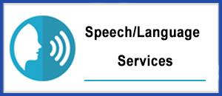
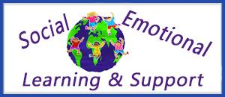

Procedural Safeguards— Facts
The Individuals with Disabilities Education Act (IDEA) is a federal law for special education. The IDEA includes protections for parents and students. These protections are called the procedural safeguards. Schools must provide a document explaining all of the procedural safeguards to parents. At AEE we provide copy of this document when a student is referred for services through our SPED Program. Copy of this document can also be found at the school’s website: www.aeetoledo.com. If you have questions regarding the Procedural Safeguards, ask your IEP team for additional information or directly at the AEE Department of Special Services (419-382-2280).

Department of Specials Services - SPED Programs and Support Staff
Dr. Israel I. Koppisch
Director, Department of Special Services
Margaret Hallett, Intervention Specialist
Hannah Jeffers, Paraprofessional
Perris Loggins, Paraprofessional
Cynthia Kennedy, School Psychologist
Lauren Notestine, Speech and Language Therapist
Alysia Kusner , Occupational Therapist
Roye Durden, Licensed Social Worker / Behavior Specialist

