ACADEMY OF EDUCATIONAL EXCELLENCE
728 Parkside Boulevard, Toledo, Ohio 43607
419-382-2280

aa
aa

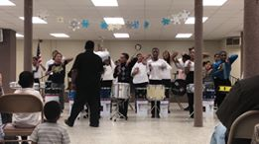

PARENT’S HANDBOOK
2020-2021

ACADEMY OF EDUCATIONAL EXCELLENCE
AN ELEMENTARY LEADERSHIP SCHOOL
Home of the Mighty Penguins
“We are family!”

ACADEMY OF EDUCATIONAL EXCELLENCE
AN ELEMENTARY LEADERSHIP SCHOOL

VISION STATEMENT:
The Academy of Educational Excellence is located on a site that is visually pleasing and reflects our mission, our values, and our school culture. The campus serves as gathering space where parents and community members can share in the richness of our school culture. AEE students enjoy coming to school and spending the day in classroom and activities that will maximize opportunities for learning. Students are holistically supported to meet or exceed grade level benchmark goals. The academic program offers a solid presentation of the core content areas with a rich diversity in extracurricular offerings. The school is well staffed to meet our mission and goals, with educational leaders, teachers, paraprofessionals and support specialists that share in the AEE mission. Collaboration between staff and other resource people provide both structure and opportunity for continuous improvement and organizational growth.

CORE VALUES STATEMENT

At the Academy of Educational Excellence, we value:
A supportive and stimulating environment that nurtures the whole child.
Empathy, Compassion, and Respect for cultural and ecological diversity are highly promoted.
A lifelong love and commitment for learning.

MISSION STATEMENT:
The mission of the Academy of Educational Excellence is to develop the whole child, allowing them to achieve their full academic potential, while preparing them for global leadership. This will be accomplished through rigorous mastery-focused curriculum including Fine Arts, foreign languages, technology, enthusiastic teaching staff, and a caring involved community.

ORGANIZATIONAL OVERVIEW:

At the Academy of Educational Excellence, we are proud to provide our students with the opportunity to learn alongside a diverse group of children and families who reflect the racial, cultural and socio-economic diversity of communities surrounding our school. Our standards-based program provides an academically challenging, creative and emotional supportive environment for our students and is designed to continually expands student’s knowledge and understanding of concepts, ideas and information. Our differentiated teaching-learning approach is the cornerstone of our instructional delivery at AEE. We offer our students the strategies for gathering information, a classroom climate of shared inquiry, and hands-on experiences making use of a variety of materials. Teachers design projects to promote collaboration between students, connect concepts between curricular areas, and anchor state standards in meaningful contexts like those students will experience in their lives beyond the classroom. Projects will be shared with our community in performances, simulations, art shows, and displays as we celebrate together the continuing joy of lifelong learning.

AEE is designed for families who are seeking innovation in education. Through our Personalized Learning Model, students participate in enrichment classes in the core subject areas of language arts, math, social studies and science. We offer a wide range of programs plus onsite intervention and enrichment curricula, including technological resources. The school provides high-quality and state adopted curricula.

GOVERNING BOARD

Charles Harrison
Chairperson

Board Members

Allison Cox
Beverly Tucker
Lena Webb
John D. Walthall III

SCHOOL ADMINISTRATION

Ann Harris
CEO/Superintendent
and Literacy Specialist

Dr. Israel Irizarry-Koppisch
CAO/ School Leader

Charlissa Blackshear
Administrative Assistant

Margaret Hallett
Intervention Specialist

Dear Parents and/or Guardians:

Thank you for selecting the Academy of Educational Excellence for your child. We are very excited about our eighth school year! We have been growing slowly but surely thanks to the community support.

At the Academy of Educational Excellence—an elementary leadership school--, we are proud to provide our students with the opportunity to learn alongside a diverse group of children and families who reflect the racial, cultural and socio-economic diversity of communities surrounding our school. Our standards-based program provides an academically challenging, creative and emotional supportive environment for our students and is designed to continually expand student’s knowledge and understanding of concepts, ideas and information.

The educational philosophy, called constructivism, is the cornerstone of our instructional delivery at AEE. We offer our students the strategies for gathering information, a classroom climate of shared inquiry, and hands-on experiences making use of a variety of materials. Teachers design projects to promote collaboration between students, connect concepts between curricular areas, and anchor state standards in meaningful contexts like those students will experience in their lives beyond the classroom. Projects will be shared with our community in performances, simulations, art shows, and displays as we celebrate together the continuing joy of lifelong learning.

Definitely AEE is designed for families who are seeking innovation in education. Through our Personalized Learning Model, students participate in enrichment classes in the core subject areas of language arts, math, social studies and science. We offer a wide range of programs plus onsite intervention and enrichment curricula, including technological resources. The school provides high-quality and state adopted curricula.

We encourage you to maintain an active role in your child’s education. As a new and growing school, we welcome your comments, feedback or questions you may have. Feel free to call or set up an appointment if you would like to discuss any matters pertaining to your child’s education and school.

Cordially yours,

Israel I. Koppisch, PhD
CAO/ School Leader

What is a charter school?
A charter school is an independently run public school granted greater flexibility in its operations, in return for greater accountability for performance. They are funded with public monies just like other public schools. However, they are not held to some of the same laws, regulations, and guidelines as regular public schools. The "charter" establishing each school is a performance contract detailing the school's mission, program, students served, performance goals, and methods of assessment.
Charter schools are a different option for public school students. They are not allowed to charge tuition, but they often have controlled enrollments and have waiting lists for students wanting to attend. Charter schools are often started by administrators, teachers, parents, etc. who feel constrained by conventional public schools. Some charter schools are also established by non-profit groups, universities, or private industries. Some charter schools focus on certain areas such as science or math and others attempt to create more difficult and a more efficient educational curriculum. The Academy of Educational Excellence is a non-profit organization.

What is the difference between charter schools and other public schools?
Charter schools are public schools of choice, meaning that families choose them for their children. They operate with freedom from some of the regulations that are imposed upon district schools. Charter schools are accountable for academic results and for upholding the promises made in their charters. They must demonstrate performance in the areas of academic achievement, financial management, and organizational stability. If a charter school does not meet performance goals, it may be closed.

Are charter schools all the same?
No. Charter schools can vary a great deal in their design and in their results. Uncommon Schools creates schools based on the principles and practices that have proven successful in producing significant academic gains at high-performing urban charter public schools across the country.

Who authorizes charter schools?
This varies from state to state, depending on the state's charter law. In Ohio, the state Department of Education authorizes the sponsor organization and the specific charter schools.

Who attends charter schools? Whom do they serve?
Nationwide, students in charter schools have similar demographic characteristics to students in the local public schools. In some states, charter schools serve significantly higher percentages of minority or low-income students than the traditional public schools. Charter schools accept students by random, public lottery.
How are charter schools funded?
As public schools, charter schools are tuition-free. They are funded according to enrollment levels and receive public funds on a per pupil basis. Charters do not receive capital funds to support facility expenses. Charter schools are entitled to federal categorical funding for which their students are eligible, such as Title I and Special Education monies. Federal legislation provides grants to help charters to manage start-up costs.
What are some benefits with charter schools?
Creators of charter schools believe that they increase learning opportunities and provide greater access for a quality education. Many people also enjoy the choice they create within the public school system for both parents and students. Proponents say they provide a system of accountability for results within public education.

One of the biggest benefits is that teachers are often encouraged to think outside the box and are encouraged to be innovative and proactive within their classrooms. This is in contrast to the belief that many public school teachers are to traditional and rigid. Charter schools advocates have stated that community and parental involvement are much higher than those in traditional public schools. With all of that said, charter schools are primarily chosen because of their high academic standards, small class sizes, ground-breaking approaches, and matching educational philosophies.

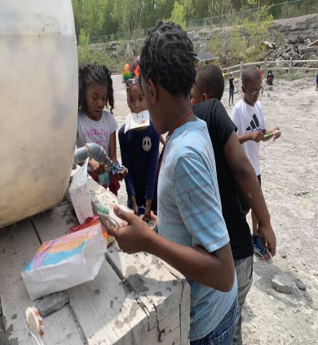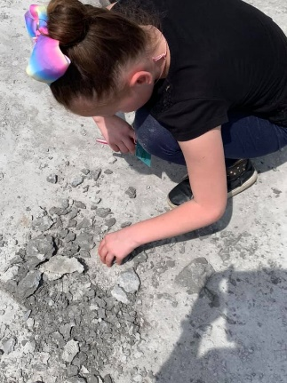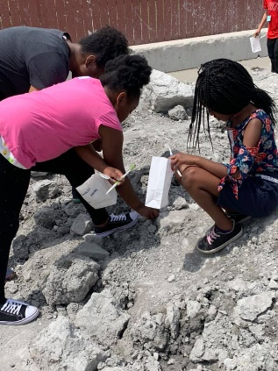

A FIELD TRIP TO FOSSIL PARK—THIRD GRADERS—2018-2019

COURSES OF STUDY

English Language Arts

Our English Language Arts Program is keyed to the notion that reading and writing are components of one process and that each supports the growth of the other. Students spend extended periods of time reading and discussing literature, and have continuous, repeated exposure to the process of writing. In this manner we are building the skills and developing the interest and confidence needed to support lifelong readers and writers, as well as the skills and strategies to ensure success in middle school and beyond.

Mathematics
Our goal for mathematics instruction is to produce students who recognize and appreciate the mathematical components of their world and the important role that mathematics will play in their future. We strive to develop student fluency with numbers supported by a strong mathematical vocabulary and solid skill base. Challenging projects that implement skills and concepts support the development of mathematical reasoning and algebraic thinking building confident problem-solvers throughout the grades. Our early focus on the application of skills readies our students for increasingly challenging math curricula.

Science
Our standards based science curriculum is built on the belief that science is a hands-on inquiry–based collaborative endeavor. Hands-on scientific experiences, supported by content rich classroom libraries, Internet resources, speakers and field trips provide a context for discovery. Students test hypotheses, expand their knowledge base, and work with classmates to develop new insights. Projects include collaborative presentations as well as more formal written research. There are many opportunities to share the joy of scientific discovery with classmates, teachers and parents.

Social Studies
We consider our social studies curriculum to be an opportunity to promote a culturally sensitive historical perspective and to inspire civic-minded participation through community service. Our social studies curriculum is aligned with Ohio State Standards, following core content expectations. Instructional delivery is focused on guiding questions and projects as we build student understanding of various historical perspectives, providing opportunities for students to explore, analyze and deepen their understanding of community, diversity and multiculturalism.

Visual and Performing Arts
Currently we expose students to the arts in two different ways: within the academic classroom setting, and in weekly subject-specific arts instruction in visual arts and music. When students learn visual and performing arts from skilled specialists, they develop a deeper and more focused appreciation and skill set than they would from integrated arts alone. For example, children learn about color and elements of line in art, and about rhythm and phrasing in music. Art and music specialists showcase student work through performances, an annual student art show, and during our weekly community traditions. Students use the arts to deepen their understanding of a subject, or share what they have learned with others. Classroom lessons often include music from the period of study, or opportunities to select art as a way to demonstrate what has been learned.

Physical Education
Physical Education, nutrition, as well as our healthy food policy, promote a connection to an active life-style as well as healthy eating habits. Our physical education program emphasizes the importance of activity, and physical education specialists use a variety of strategies to promote engagement and teambuilding as well as fitness. Dance and the use of music are both integral components of our program.
Assessments
In the elementary program students are assessed using a variety of instruments in order to determine flexible groupings. Periodically we assess our students in order to be able to follow-up their achievements and educational growth. On a quarterly basis our instructional staff are able to see every child’s progress and/or areas that need more attention in order to promote their learning achievement.
Literacy
In the AEE elementary program we feel literacy is the key to accessing all learning. Classroom teachers utilize a blend of programs and materials to instruct students in reading and writing. The core program of instruction addresses the 5 components of literacy: phonemic awareness, phonics, fluency, comprehension, and vocabulary. A large portion of the writer’s workshop involves student writing and conferencing. Students receive spelling instruction through a word study approach. Word study uses categorization and activities that encourage word play and manipulation to help students explore word patterns and internalize spelling rules.
Technology
Technology plays a very important role in the classroom today and can be used to teach important concepts in almost every subject area. It is imperative that teachers become comfortable with many forms of technology. We are excited to announce that 100% of our classrooms in grades K-6 have a Smartboard. Teachers are creating lessons that are more interesting, motivating and engaging for our students. The students are working on developing typing skills, accessing interactive websites, and utilizing software such as Excel and PowerPoint. In grades 3-6 these skills continue to be addressed in a more content-integrated fashion as students use classroom computers and travel to the computer lab. Incorporating new technology with traditional teaching methods will help to make instruction more comprehensive, engaging and interactive.
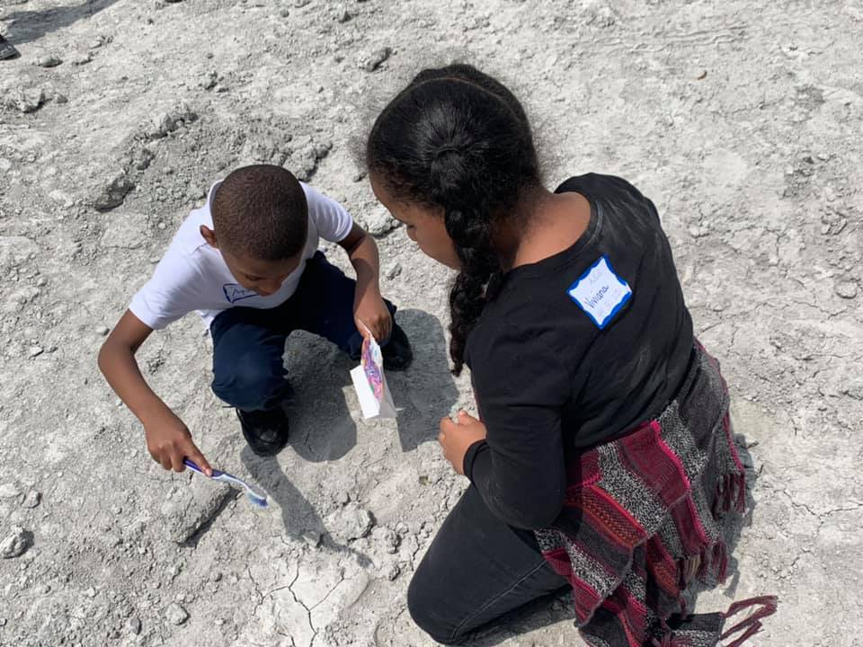 FIELD TRIP TO FOSSIL PARK—SECOND GRADERS- 2018-2019
Enrichment Classes
Enrichment Classes Planned for 2019-2021 (additional classes to be added)
- Oral and Written Language
- Arts and Crafts
- Exploring Science
- World Cultures
- Field Trip Study Unit
- Life Skills
- Drum Lines
- Stepsides

Field Trips

The K-6 Independent Study program provides a variety of educational based field trips for our students to attend. Our faculty members will plan field trips to enrich their class lessons according to curricula needs. Students may attend an Enrichment Study Unit to learn about important aspects of each field trip.

Intervention

The K-6 Differentiated Education Program takes pride in addressing the needs of our students. Time is set aside to provide intervention for individuals who have demonstrated a need through state assessment, local assessment, and course progress.

The K-6 Differentiated Education Program may require that a Student Study Team meeting is held in order for intervention to be discussed and needs evaluated. Intervention sessions take place individually or in small groups based on the needs of the students.

ACADEMY OF EDUCATIONAL EXCELLENCE
STUDENT CODE OF CONDUCT

At the Academy of Educational Excellence all students are expected to conform to the Student Code at school, on school premises, at school activities or functions whether on or off the school premises, and on transportation to and from School, if paid for and provided by the school and are subject to the school’s disciplinary process when they fail to do so.

Parents can support our program by reviewing the school rules below:

BE SAFE BE RESPECTFUL BE RESPONSIBLE

These rules will be reviewed by teachers throughout the school year so that all students are aware of them. Consequences for breaking the rules may involve a time out or missed recess, teacher communicating with parents or conference with School Principal, parent, teacher and student.

It is the school intent to provide a safe, orderly and nurturing environment that is free from any form of harassment or bullying. Serious offenses will result in immediate referral to the office for possible disciplinary action –including suspension and/or expulsion from school. A student’s due process rights will be observed in all such instances, including the right to appeal the discipline decision of staff and/or administrators.

UNACCEPTABLE BEHAVIORS

- Bringing to school, possessing, concealing using a weapon, or replica of a weapon, on school property and/or transportation system.

- Substance abuse or any possession, use, distribution or sale of tobacco, alcohol or unlawful drugs, including drug paraphernalia.

- Use of threats, intimidation or harassment, including mean-spirited teasing or bullying.

- Assault or menacing of a district employee, school employee or another student.

- Open defiance of a teacher’s or administrator authority.

- Willful damage or destruction of school property or employee’s property.

- Use or display of profane or obscene language.

- Leaving school campus or other school-sponsored events without permission.

- Theft

- Violations of district transportation rules.

- Sexual harassment and/or touching other student’s bodies

- Persistent failure to comply with rules and regulations under the direction of school staff members.

ATTENDANCE

Regular attendance is absolutely essential to learning and success in school. The State of Ohio law recognizes the importance of attendance to school by providing as follows:

“ All students between the ages of 5 and 18, who have not completed grade 12,
are required to attend school unless otherwise exempted by law”.

School staff will monitor daily and report violations of the state compulsory attendance law.

In elementary school where most learning is interactive and hands-on, it is impossible to duplicate the learning experiences with make-up assignments. It should be recognized by students and parents that every absence adversely affects a student’s learning process. While we do not want students who are ill to be in school, we do not want student or parents to feel that almost any excuse justifies absence from school.

The following policies will be in effect for attendance:

EXCUSED ABSENCES An absence may be excused if the absence is caused by the student’s sickness,
a serious illness of some member of the pupil’s family which needs the student’s presence at home, doctor’s or dentist’s appointments, or by an emergency. The Principal and/or teacher may also excuse absence for other reasons when satisfactory arrangements are made in advance of the absence.

Family trips during scheduled school days are completely discouraged but may be approved where satisfactory arrangements are made in advance of the absence. Trips forms are available at the school office.

PROCEDURE Please call the school not later than 9:30am when your child will not be in
attendance.

Following an absence send the teacher a written note with:

- Name of child
- Date(s) of absence
- Reason for the absence
- Attending physician, if any
- Parent’s / Guardian signature.
According to district’s administrative procedure parents of students who are absent more than 20% of the days during the school year, receive an attendance letter stating our concern that excessive absences can negatively affect student learning and grades. Students attending AEE on in-district transfers must comply with the attendance regulations to maintain their placement.

A student who don’t comply with attendance regulations may be retained in the same grade for the next year.

MAKE-UP WORK Whenever school is missed, it is the student’s responsibility to make-up for missed assignments and/or classwork, as directed by the classroom teacher.

TARDINESS School begins at 9:00am—daily.

Being on-time is an important value in our society. Because tardiness causes loss of instructional time for teachers and learning time for students, we request all students to arrive at least 15 minutes ahead of time.

Students who arrive after 9:00am are to report to the school office and will be issued a LATE PASS TO CLASS. The student should have a written note from their parent explaining the reason for the tardiness –IN ORDER TO HAVE A LATE PASS TO CLASS ISSUED.

CHANGE IN ROUTINE If you wish to change your child’s routine in any way—walk home when he/she usually rides the bus, go home with another child, etc., we must have a WRITTEN PERMISSION during the morning. Except in cases of emergency, we ask parents not to make calls in request for change as this involves interrupting teaching and learning time.

School office will not receive phone calls after 2:30pm.

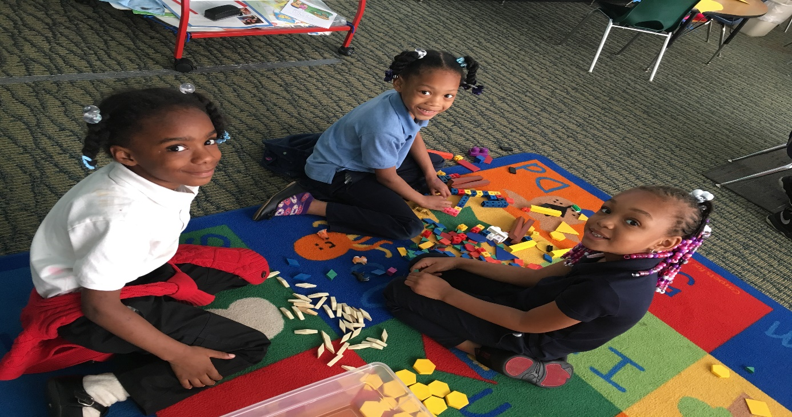

2018-2019 KINDERGARTERNERS AT WORK

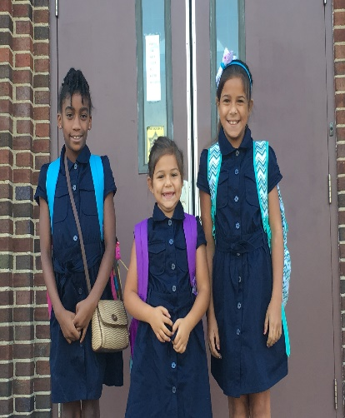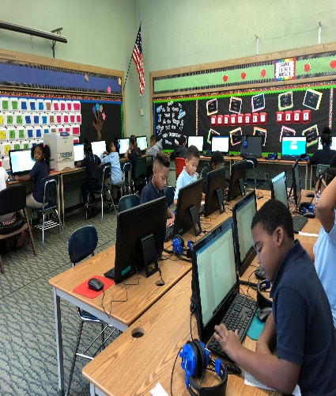

KINDERGARTENERS HAPPY LEADERS!!! AEE TECHNOLOGY LAB

FOOD ALLERGIES

Because of the rising number of students allergic to peanuts and peanut products, we ask that food to be shared with others at school for parties, snacks, etc., be free of peanuts or labeled containing peanuts.

FOOD PREPARATION

The Lucas County Health Department recommends that all foods brought from home to be shared with others, be commercially prepared and packaged. They make this recommendation as viruses can be transmitted via home-prepared snacks.

MICROWAVE USE

AEE Faculty and/or staff WILL NOT be able to warm packed lunches in the microwave for students. If you choose to pack your children lunch, it must be ready to eat. We cannot warm up or wash out any containers, wrapped sandwiches or meals. These rules apply to students as well.

STUDENTS TRANSPORTATION
AEE HAS ITS OWN TRANSPORTATION DEPARTMENT

SCHOOL BUS

Student transportation is a service and privilege provided by the school to responsible students. Students failing to follow bus regulations may be denied transportation services and shall be subject to disciplinary action.

Student conduct must be such that the drivers are able to focus their full attention on the driving of the bus.

Students are not allowed to be moving around the bus or playing on the bus while it is in movement.

BULLYING IS NOT PERMITTED AT ALL AT AEE AND/OR IN THE BUSES. Any student who is accused of bullying any other student on the bus – may be denied transportation services and shall be subject to disciplinary action.

STUDENT DROP-OFF AND PICK-UP

Vehicles parked on school property are under the
jurisdiction of the school.

Children transported to or from school in private
vehicles should be dropped off and picked up in the
designated areas in the front parking lot.

Traffic patterns and parking areas are designed for
student safety.

KINDERGARTEN STUDENTS are NOT to walk home
alone--- please have someone come to school or bus
stop to meet them. THIS IS NON-NEGOTIABLE.

Students, whose parents are not at the stop to receive
them, will be taken to the bus yard and parents are
responsible for picking their student up.

BICYCLES
Fourth, fifth and sixth graders students are allowed to
ride bicycles to school.

Students riding on sidewalks or otherwise
endangering others will lose the privilege of riding
bicycles to school.

The school is not responsible for lost or stolen
bicycles.

Students are required to wear a bike helmet.

SKATES, SKATEBOARDS AND SCOOTERS
Students are NOT allowed to ride or bring skates
(including built-in shoe skates) roller blades, scooters
or skateboards to school.

VISITORS

Parents and other visitors are encouraged to visit the school. To ensure the safety and welfare of students, ALL VISITORS must report directly to the school office upon entering school property.

NO PARENT AND/OR VISITOR IS ALLOWED TO PASS DIRECTLY TO THE CLASSROOMS WHILE SCHOOL IS IN SESSION. ALL PARENTS AND/OR VISITORS MUST SIGN-IN AT SCHOOL ENTRANCE WHEN ENTERING SCHOOL PREMISES.

PARENTS AND/OR VISITORS ARE NOT TO DISRUPT CLASSES.

STUDENT VISITORS ARE NOT ALLOWED DURING REGULAR SCHOOL HOURS.

YOUNGER SIBLINGS CANNOT ACCOMPANY PARENTS WHEN CHAPERONING FIELD TRIPS OR ANY OTHER SCHOOL ACTIVITY.

PARENTS CAN COORDINATE WITH TEACHER’S A VISIT TO THEIR CHILD’S CLASSROOM IN ORDER TO OBSERVE HIM/HER.

SCHOOL—PARENTS COMMUNICATIONS

NEWSLETTER A monthly newsletter is published by the School Leader’s Office. These newsletters contain general information about students, staff and programs. The newsletter will be sent home every quarter. Watch for it in order to keep yourself informed of all school news.

GRADES AND
CONFERENCES Student academic progress will be evaluated at the end of each quarter (9 weeks).

Parent-teacher conferences will be scheduled with parents in every quarter. Additional conferences may be scheduled whenever the need arises.

Students will take home report cards on week after the end of the quarter. PARENTS ARE TO SIGN AND RETURN REPORT CARDS TO SCHOOL.

PROMOTING STUDENT SUCCESS

I want my child to succeed in his education. Therefore, I will encourage him/her by doing the following:

- Reinforce School Rules and Regulations.
- See that my child is punctual and attends school regularly.
- Establish a time and place for homework, reviewing that homework on a daily basis.
- Support the school in developing positive behavior. As a parent I will support the school discipline policy –at all times.
- Provide a home environment that encourages my child to learn.
- Send my child to school each day with pencils, pens, paper and other basic and necessary tools. It’s the parent’s responsibility to provide school supplies.
- Promote education by setting examples of a school environment.
- I will communicate with the school personnel and develop a working trust with the child’s teacher.
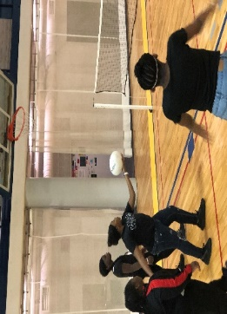
AEE DRUMLINES PERFORMANCE 5TH-6TH GRADES FUN DAY- UT

AEE SCHOOL RULES

To make AEE a Safe Environment:

- Students and parents will treat everyone with dignity and respect at all times!
- Students will play practicing good sportsmanship.
- Students will follow all safety rules.
- Students will not bring dangerous items or toys to school.
FOR AEE TO BE A GREAT PLACE TO BE:

- Students are expected to show respect to all staff members and give his/her best efforts in the learning environment.

- Students are expected to follow school and classroom rules.
REWARDS AND INTERVENTIONS

Responsible behaviors by students result in a safe, comfortable and productive school environment. AEE rewards responsible behavior in a variety of ways:

- REWARDS
  - Awards
  - Privileges

- INTERVENTIONS

  - Verbal reminder/warning
  - Re-teach expectations
  - Loss of privileges
  - Parent notifications or referral
  - Suspension/expulsion
  - Please note: a referral is serious! This is input placed into the district data system and becomes part of the student’s permanent K—6 record.
  - Suspensions and expulsions are included in the year end district and state reports.

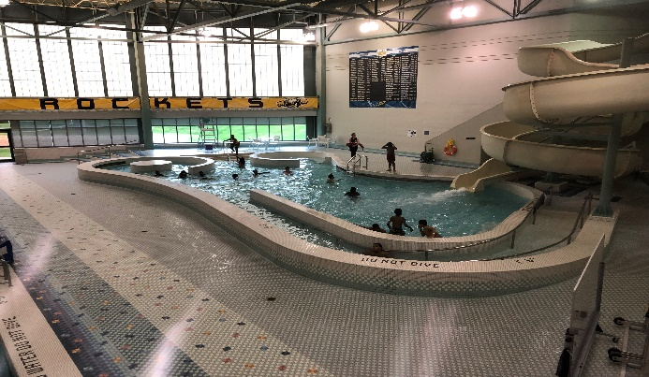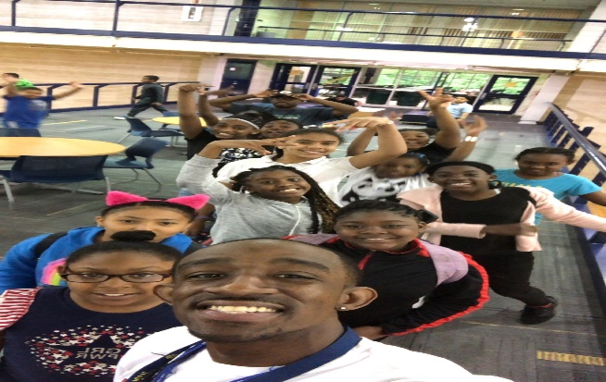
4TH—5TH GRADERS FUN- DAY-- UT

RULES AND REGULATIONS

HALLWAY RULES

GOAL: The hallways of AEE will be a safe and quiet environment where people interact with courtesy and respect—at all times. STUDENTS ARE TO WALK AT ALL TIMES.

EXPECTED RESPONSIBLE HALLWAY BEHAVIOR

- Students will walk, facing forward, through the walkway areas.
- Stay to the right except when directed otherwise by an adult.
- Keep hands, feet, and objects to yourself.
- A minimal amount of talking will be used in the hallways. If someone is too far away to hear, move close enough to speak in a quiet voice.
- Ignore students who are sitting or working in the hallway.
- During class time, students must be continuously walking toward their destination to be in the walkways.
- At morning bell and dismissal times, students must follow assigned routes to destinations.
- Everyone will be treated with dignity and respect.
- NO BULLYING IS PERMITTED AT ANY TIME IN SCHOOL PREMISES.
- If a staff member asks to speak with a student, the student will stop and talk with that person.
- During recess times, students must have a pass to be admitted to the library/media center, office and/or restrooms.
- If a staff member requests that a student correct a behavior, the student will comply respectfully.
BEFORE SCHOOL / AFTER SCHOOL

GOAL: Students will arrive and depart school in a safe and orderly manner – NO RUNNING OR SCREAMING IS PERMITTED AT ANYTIME.

- Students who eat breakfast may arrive at 8:30am.
- Student arrival times: 8:30—8:40am
- Class starts at 9:00am.
- Students who eat breakfast will wait by the cafeteria door until the Cafeteria opens. Students must line up outside before school.
- If weather conditions cause students not to stay outside, students will be allowed to stand QUIETLY in the hallway. RESPECTFUL BEHAVIOR IS EXPECTED AT ALL TIMES.
- Students are expected to form an orderly line outside the classroom and/or cafeteria and wait quietly, peacefully and calmly before school starts.
- When entering the building, students will walk in a quiet and orderly manner to their classrooms following designated routes.
- Upon dismissal; students will proceed to the bus loading area or car pick-up area. Students are expected to load busses immediately.
- After School Programs students and/or chauffeured students may go to the designated areas.
- Dismissal areas will be monitored to expedite departure and insure proper safe behavior.
- Safety rules are to be observed at all times.
- Students need to go directly home after school.

AEE SCHOOL CAFETERIA
School Food is Catered by Club 300

GOAL: The cafeteria area will be a safe and clean place where people interact with courtesy and respect.

EXPECTED RESPONSIBLE CAFETERIA BEHAVIOR:

COMING TO THE CAFETERIA AND IN THE SERVICE LINE:

- Students come to the cafeteria in an orderly line, quietly, peacefully and calmly.
- While in line, students will keep hands, feet, and objects to themselves.
- No playing around the tables is permitted.
- Students will use quiet voices in the service line and throughout the breakfast/lunch period.
- Students will face forward and keep line moving.
- Students will hold plate/tray with both hands.
- Students will be respectful and courteous to cafeteria personnel.
- NO SHOUTING IS PERMITTED AT ANY TIME.
- Students will sit in the designated areas for their grade.
- Tables will be kept clean and in order AT ALL TIMES.
- Students will throw away their plates into the trash cans provided in the cafeteria.
CAFETERIA AREA EXPECTED BEHAVIOR:

- Students are expected to demonstrate respectful, safe, responsible behavior AT ALL TIMES.
- Students will use quiet voices when talking (level 1—2).
- Students will use polite language and respectful tone of voice.
- Students will keep hands, feet and objects to themselves.
- Students will stay in their seats and raise hands to get help or be excused.
- Students will use good manners while eating.
- Students will keep food to themselves without sharing, FOR HEALTH AND SAFETY REASONS.
- Students WILL USE UTENSILS TO EAT WITH.
- Students will properly sit on the chairs.
- Everyone will treat others with respect.
- Students must have a written permission to not eat and must wait to go outside until class is dismissed.
- Parents must provide written medical excuse if students cannot have milk or lactose related meals.
- School will provide monthly cafeteria menu to all families. Parents must provide food for their children if for any reason don’t want food provided in the daily menu.
CAFETERIA DISMISSAL:

- Cafeteria monitors will dismiss students for recess.
- Children must raise hand to be dismissed from Cafeteria.
- The Cafeteria Area must be cleaned up (pick up wrappers, containers, etc.) and students must be quiet to be recognized.
- When dismissed, at the assigned dismissal time, students will clean-up, as directed.
- Lunch boxes are to be left in designated areas and picked up at the end of recess.

BREAKFAST AND LUNCH PROGRAMS

BREAKFAST PROGRAM:

- All students are presented with a breakfast to start their day.
- The Breakfast Program is FREE for all AEE students---regardless of home income.
- The program is optional — if your child wishes to not have their breakfast they simply let the teacher/cafeteria monitor know daily. This is a great program that insures every student to get off on the right foot.

LUNCH PROGRAM:

- All students are presented with a LUNCH daily.
- The Lunch Program is FREE for all AEE students---regardless of home income.

- The program is optional — if your child wishes to not have their lunch they simply let the teacher/cafeteria monitor know daily. This is a great program that insures every student to have a balanced meal according to the provided daily menu.
MICROWAVE USE:

- AEE Faculty and/or Staff WILL NOT be able to warm packed meals in the microwave for students. If you choose to pack your child’s lunch, it must be ready to eat. WE CANNOT WARM UP OR WASK OUT ANY CONTAINERS, WRAPPED SANDWICHES OR MEALS. These rules apply to Students, as well.

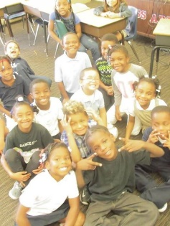

“IN ACCORDANCE WITH FEDERAL LAW AND U.S. DEPARTMENT OF AGRICULTURE POLICY, THIS INSTITUTION IS PROHIBITED FROM DISCRIMINATING ON THE BASIS OF RACE, COLOR, NATIONAL ORIGIN, SEX, AGE, OR DISABILITY. TO FILE A COMPLAINT OF DISCRIMINATION, WRITE USDA, DIRECTOR, OFFICE OF ADJUDICATION, 1400 INDEPENDENCE AVENUE-SW, WASHINGTON, D.C. 20250-9410 OR CALL TOLL FREE (866) 632-9992 (VOICE). INDIVIDUALS WHO ARE HEARING IMPAIRED OR HAVE SPEECH DISABILITIES MAY CONTACT USDA THROUGH THE FEDERAL RELAY SERVICE AT (800) 877-8339; OR (800) 845-6136 (SPANISH). USDA IS AN EQUAL OPPORTUNITY PROVIDER AND EMPLOYER.”

HARASSMENT REFERRAL PROCEDURE

HARASSMENT IS: UNWELCOME WORDS OR ACTIONS THAT CREATE A HOSTILE ENVIRONMENT. Unwelcome means the person doesn’t like it. It may hurt the person’s feelings, embarrass the person or make the person angry.

Treating people differently just because they are a boy or a girl.
(Make jokes about the person / name calling/ comments made about a person’s physical appearance / racial comments/ threats)

IT IS AGAINST THE LAW! Any person and/or student can be accused of harassment even if the intention was a harmless teasing or flirting or just being funny. It’s how the other person feels about the words or acts.

PROCEDURE IS USED WHEN:

- A student is being harassed and goes to a staff member for help.
- A staff member witnesses a student harassing another student.
CONSEQUENCES – LEVEL 1, 2, 3

LEVEL 1: PROCEDURE

- Teacher or supervising adult issues a written misbehavior referral.
- Student/ Principal/ or supervising adult conference.
- Re-teaching takes place identifying harassing behavior.
- Parents are notified of harassment by phone OR in writing. Referral is sent home for parent signature.
- Consequences are administered. Students may lose privileges – including being able to participate in school offered services.
- Student serves consequences as administered by the School Principal or supervising adult.
- Student completes Consequence/Level1, Part 1: Time to Think it Out.
- When a student has three (3) offenses, the penalty advances to a Level 2.
LEVEL 2: PROCEDURE

- Teacher or supervising adult issues a written misbehavior referral.
- Student and Principal or supervising adult conference. Re-teaching takes place identifying harassing behavior.
- Parents are notified of harassment by phone and/or in writing. Referral is sent home for parent signature.
- Consequences are administered. STUDENT IS SUSPENDED FOR 1-3 DAYS BY THE SCHOOL PRINCIPAL.
- Students completes Consequence Level 2, Part 1 and Part 2.
- Incident is documented in the student’s permanent record.
LEVEL 3: PROCEDURE

- Teacher or supervising adult issues a written misbehavior referral.

- Student and School Principal or supervising adult conference. Re-teaching takes place identifying harassing behavior. Parents are notified of harassment by phone/writing. Referral is sent home for parent signature.

- Consequences are administered. STUDENT IS SUSPENDED FOR 3-5 DAYS BY SCHOOL PRINCIPAL. DEPENDING MAGNITUDE OF INCIDENT STUDENT MAY BE EXPELLED FROM SCHOOL.

- Incident is documented in the student’s permanent record.

SEARCHES:
Be it known that school and district officials may search the student, his personal property and property assigned by the district for the student’s use at any time there is reasonable suspicion to believe evidence of a violation of a law or emergency/dangerous circumstances exist.

PROBLEM SOLVING:
In elementary school, teachers and administrator spend considerable time teaching children how to solve problems peacefully. Students are encouraged to solve minor disputes that arise on the playground, buses, hallways, cafeteria or any other school premise, using their own problem solving skills with assistance from any adult.

USE OF AEE RESTROOMS

GOAL: The restrooms at AEE will be clean and safe.

EXPECTED RESPONSIBLE RESTROOM BEHAVIOR:
- Students will walk in restrooms.

- Students will use restroom facility safely and appropriately by:
  - Keeping feet on the floor.
  - Keeping water in the sink.
  - Using soap and water for washing hands.
  - Placing towels in the garbage can.
  - Flushing toilet after use.
  - Reporting any problems to an adult.
  - Avoiding sneaking/picking underneath the bathroom divisions.
  - Respecting every other student privacy.

- Students will be respectful by:
  - Keeping hands, feet and objects to self.
  - Keeping the area clean.
  - Talking quietly.
  - Waiting patiently for their turn.

- Vandalism of restrooms will result in locking the restroom for a time during clean-up.
  - Students may be asked to clean or correct the vandalism depending on the severity.
  - Marker, pencil, painting and throwing paper around are subject to clean up by student, with the exception of any act that may need chemicals or mopping.
  - Parents will be contacted in the event of any act of vandalism done by their child.
  - Cost of fixing any repairs will be invoiced to parents.
  - Student causing any act of vandalism can be SUSPENDED AND/OR EXPELLED FROM SCHOOL.

HEALTH POLICIES

IMMUNIZATIONS:
State law requires that children entering Ohio schools for the first time be immunized.
Immunizations may be obtained at the Lucas County Health Department.

MEDICATION AT SCHOOL:

- If your child must depend on medication at school, you should discuss the matter with the Office staff and/or your child’s teacher. School personnel MAY NOT dispense or administer medication to a student except upon written order of PHYSICIAN and/or signed request from the parent and/or guardian.

- Medication shall be properly labeled with the student’s name, name of medication, dosage route, frequency of administration, any special instructions and the doctor’s name.

- All medication to be administered by the district is to be brought to school by the parent in the original container with the prescription on the container.

- Medication not picked up by the parent within five (5) school days of the end of the medication period or at the end of the school year, whichever occurs first, will be disposed of by the district.

EMERGENCY MEDICAL TREATMENT:
- A student who becomes ill or is injured at school must notify his teacher or another staff member as soon as possible.

- In case of serious illness or injury, the school staff shall attempt to notify parents according to the emergency information provided on registration forms. PARENTS SHOULD UPDATE THIS INFORMATION WHENEVER THEY MOVE OR CHANGE THEIR TELEPHONE NUMBERS. This information is to be updated as often as necessary.

- If school staff cannot reach parents/guardians in the provided telephone numbers, and students situation merits to do so, they will call 9-1-1 for assistance.

- School staff may administer emergency or first aid, if possible. The school will contact emergency medical personnel, if necessary, and will attempt to notify the student’s parents whenever the student has to be transported to treatment.

COMMUNICABLE DISEASE:
Parents are urged to contact the school office with information regarding any communicable diseases contracted by a child. This information will help the school to keep other families informed of the possibility of disease transmission.
Communicable diseases include: chicken pox, whooping cough, scabies, staph or strep infections, ringworms infections or lice infections. STUDENTS CANNOT ATTEND SCHOOL UNTIL PHYSICIAN ALLOWS IN WRITING FOR SUCH ACTION TO TAKE PLACE.

2019-2021 STUDENT’S DRESS CODE
DRESS CODE BENEFITS
The Academy of Educational Excellence Governing Board has a mandatory dress code for all elementary school students.

Research has concluded that students are able to perform at their highest level in a safe and secure environment. A strong correlation exists between student appearance and the perception and/or reality of school violence. Prevents disruption, and minimizes safety hazards

The District’s dress code is established to teach grooming and hygiene as well as the above stated research.
In addition, there are many positive reasons for a school dress code, including:
- A dress code encourages students to express their individuality through personality and academic achievements, not outward appearances
- A dress code puts the focus on academics, not fashion, because they project a neat, serious, businesslike image
- Schools with dress codes have fewer discipline problems because students aren't distracted
- Dress codes can be less expensive
- Dress codes eliminate the visible differences between needy and wealthy children
- Dress codes eliminate pressure to wear brand name clothing, "gang colors," etc.
- Dress codes create a sense of school pride and belonging

Shirts and Blouses
Boys: White or light blue long-sleeve or short sleeve POLO shirts.
Girls: White, ¾-sleeve or long-sleeve Oxford blouses.

SWEATERS AND VEST
Boys may wear navy blue sweater or vest
Girls may wear navy blue or white sweaters

Boy’s PANTS:

Navy blue pants (pleated or plain front) with belt loops.

Girl’s shirts:

Navy Blue, pleated plaid knee -length skirts OR

GIRL’S JUMPERS:

Navy blue jumpers knee-length

Dresses:

Short- or long-sleeve mesh polo pleated dress, in plaid navy

Socks/Tights:

Socks must be worn at all times. Navy, white or black (leggings or tights for girls are acceptable).

Shoes
No Uggs, Ugg moccasins, sandals, slippers or boots are allowed during school hours. ·

Black walking shoes only!

No sneakers should be worn with school uniforms.
Sneakers with shoelaces are required for physical education.

Summer Dress Code
- From May 15–October 1: polo’s, navy blue, polo shirts and navy blue knee-length shorts may be worn (boys/girls)

Fleece/Hoodies
- Hoodies, Fleece tops and outerwear is not permitted with school uniform during a regular school day.
- Hoodies and fleece tops may be worn on jeans days only.

Jeans Days
- Denim pants, jeans, skirts or school T shirts and cargo pants should be neat, clean and in good repair without holes.
- School t-shirts can be worn during field trips and on jean days (available through our school office)
- No inappropriate style or message is allowed. Dates to be announced by principal.

OTHER DRESS CODE RULES
- A plain black belt is required if the garment has belt loops.
- Shirts (including t-shirts) must be tucked
- Shorts/skirts must be knee length
- Clothes must be appropriate size, with waist of garment worn at student's waist
- Clothing that is too tight or too loose is not appropriate for school.
School administrators will determine if clothing is appropriate for school and complies with district rules. Student’s will NOT be allowed to attend school without appropriate school uniform.

WINTER / COLD WEATHER
On very cold days, students who walk, bike, etc. may need to wear sweatpants, etc. over their school clothes on their way to/from school / bus stop. However, any clothing that doesn’t meet dress code requirements must be removed before school begins.

Jackets, sweaters, coats, etc.

Any kind of jacket/coat/cardigan is OK if it meets regular dress code** rules:

· May not be disruptive, distracting, display offensive language/symbols, etc.
· School staff may ask students to remove jackets
· Any pullover garment that is worn all day (sweater, sweater vest, sweatshirt) should:
- have a collar OR be worn with a collared uniform shirt or official school t-shirt underneath
- must be solid white, solid navy or the school’s additional solid shirt color (school sweatshirts with no hoods are OK)
- must not have any colored trim, stripes, decoration, etc. (small logos are OK)

Mrs. Autumn Fox—TEACHER OF THE YEAR 2019
Mr. Brian Cook- TEACHER AIDE OF THE YEAR 2019

AFTER SCHOOL ENRICHMENT PROGRAM

The Academy of Educational Excellence offers to all students an After School Enrichment Program. After spending a long day at school, children are encouraged to enjoy a snack and then unwind in a classroom designed with their interests in mind. Most furniture is larger to accommodate growing children, and materials are age appropriate. Activities are scheduled to provide fun, relaxation, and stimulation, including outdoor play on a daily basis. Homework time is included, and help is provided if necessary.

At AEE we believe that success is within the reach of every child. We believe every girl and boy deserves a safe place to learn and grow; ongoing relationships with caring adult professionals; life-enhancing programs, character development experiences, and hope and opportunity for the future.
At AEE our educational programs are carefully designed to support the achievement of our young people leaving. These outcomes are:
- Positive self-identity
- Educational, social, emotional & cultural competencies
- Community and civic involvement
- Health & well being
- A moral compass

AEE AFTER SCHOOL PROGRAM GOAL: PROMOTE ACADEMIC SUCCESS, develop GOOD CHARACTER & CITIZENSHIP, and adopt HEALTHY LIFESTYLES.

FUNDING AND SUSTAINABILITY
Securing funding is critical to the sustainability of our after school program. The Academy of Educational Excellence is a NOT FOR PROFIT organization. All the funds allocated by the Ohio Department of education are geared specifically for the educational program offered Kinder through 5th grade. The After School Program is not included in the funding received by AEE from ODE.

Starting with school year 2019—2020 AEE will continue to offer our After School Program to students who need to stay after school dismissal and whose parent’s pick-up before 5pm.

As part of our After School Program students will have time to work on their homework and a Tutor will be available after school hours to provide assistance to students who need additional assistance in Reading or Mathematics.

A whole-school transformation process
the LEADER IN ME
OVERVIEW

Using Best Practices and Universal Principle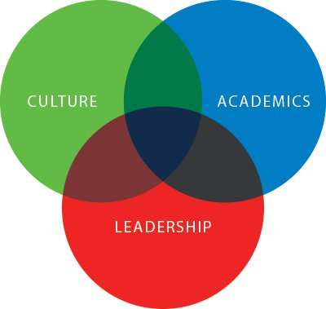s

Leader in Me® is a whole-school transformation model and process developed in partnership with educators that empowers students with the leadership and life skills they need to thrive in the 21st century. It is based on principles and practices of personal, interpersonal and organizational effectiveness, and upon the powerful premise that every child possesses unique strengths and has the ability to be a leader.

Leader in Me helps students learn how to become self-reliant, take initiative, plan ahead, set and track goals, do their homework, prioritize their time, manage their emotions, be considerate of others, express their viewpoint persuasively, resolve conflicts, find creative solutions, value differences, and live a balanced life. The process helps students develop the skills and self-confidence they need to lead their lives and succeed in school and beyond.

Leader in Me started with one school in North Carolina and has since grown to thousands of schools in over eighty countries throughout the world.

The Academy of Educational Excellence is a Leader in Me school. The 2019-2020 will be the third year of TLIM implementation.

POSITIVE BEHAVIOR INTERVENTION SUPPORT (PBIS)
OVERVIEW
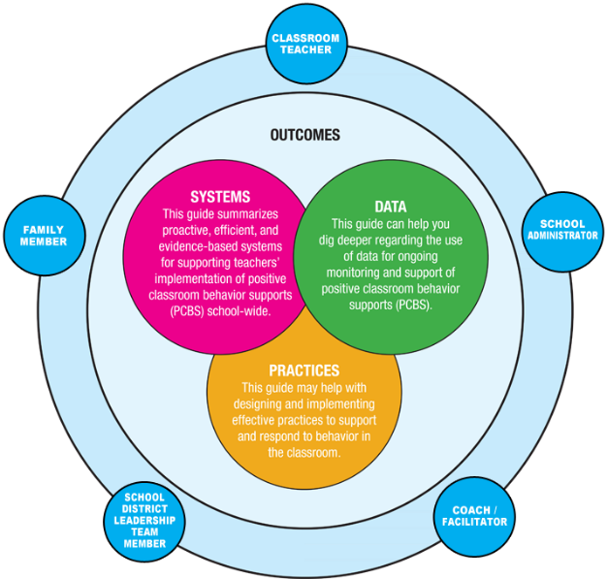

EE and PBIS in the Classroom
When PBIS is implemented in the classroom, it may be referred to as classroom PBIS, positive classroom behavior support (PCBS), positive and proactive classroom management, or a variety of other synonyms. The same critical features (practices, data, and systems) come together to promote desired outcomes for students and educators in the classroom.
- Classroom PBIS practices include preventative and responsive approaches that may be effectively implemented with all students in a classroom and intensified to support small groups or a few individual students.
- Systems refer to the structures and supports district and school leadership teams provide to enhance teachers' implementation of classroom PBIS practices with fidelity.
- Data are an active, dynamic part of decision-making in the classroom that allow educators to identify patterns of strengths and needs. Those patterns drive decision making to continue, adopt, or modify classroom PBIS practices and systems.
The school will focus on three to five behavioral expectations that are positively stated and easy to remember. In other words, rather than telling students what not to do, the school will focus on the preferred behaviors. Here are some examples from other schools:
- Respect Yourself, Respect Others, and Respect Property
- Be Safe, Be Responsible, Be Respectful
- Respect Relationships and Respect Responsibilities

This matrix will have approximately three positively stated examples for each area. Here is an example column from one school:

Respect Property
Bus | - Keep feet and hands where they belong.  - Throw unwanted items in wastebasket.  - Keep food and drinks in backpack.
Cafeteria | - Place tray on kitchen window shelf after scraping leftovers into wastebasket.  - Wipe table with sponge provided.  - Clean food spills off floor.
Restroom | - Flush toilet after use.  - Use two squirts of soap to wash hands.  - Throw paper towels in wastebasket.
Playground | - Report any graffiti or broken equipment to adult on duty.  - Return playground equipment to proper area.  - Use equipment as it was designed.
Classroom | - Put belongings away when you enter the room.  - Keep your work space clean and organized.  - Use materials for their intended purpose.

ACADEMY OF EDUCATIONAL EXCELLENCE Academic Calendar | - 2020-2021

August 2020  S M T W T F S  1  2 3 4 5 6 7 8  9 10 11 12 13 14 15  16 17 18 19 20 21 22  23 24 25 26 27 28 29  30 31 |  | September 2020  S M T W T F S  1 2 3 4 5  6 7 8 9 10 11 12  13 14 15 16 17 18 19  20 21 22 23 24 25 26  27 28 29 30 |  | October 2020  S M T W T F S  1 2 3  4 5 6 7 8 9 10  11 12 13 14 15 16 17  18 19 20 21 22 23 24  25 26 27 28 29 30 31
November 2020  S M T W T F S  1 2 3 4 5 6 7  8 9 10 11 12 13 14  15 16 17 18 19 20 21  22 23 24 25 26 27 28  29 30 |  | December 2020  S M T W T F S  1 2 3 4 5  6 7 8 9 10 11 12  13 14 15 16 17 18 19  20 21 22 23 24 25 26  27 28 29 30 31 |  | January 2021  S M T W T F S  1 2  3 4 5 6 7 8 9  10 11 12 13 14 15 16  17 18 19 20 21 22 23  24 25 26 27 28 29 30  31
February 2021  S M T W T F S  1 2 3 4 5 6  7 8 9 10 11 12 13  14 15 16 17 18 19 20  21 22 23 24 25 26 27  28 |  | March 2021  S M T W T F S  1 2 3 4 5 6  7 8 9 10 11 12 13  14 15 16 17 18 19 20  21 22 23 24 25 26 27  28 29 30 31 |  | April 2021  S M T W T F S  1 2 3  4 5 6 7 8 9 10  11 12 13 14 15 16 17  18 19 20 21 22 23 24  25 26 27 28 29 30
May 2021  S M T W T F S  1  2 3 4 5 6 7 8  9 10 11 12 13 14 15  16 17 18 19 20 21 22  23 24 25 26 27 28 29  30 31 |  | June 2021  S M T W T F S  1 2 3 4 5  6 7 8 9 10 11 12  13 14 15 16 17 18 19  20 21 22 23 24 25 26  27 28 29 30 |  | July 2021  S M T W T F S  1 2 3  4 5 6 7 8 9 10  11 12 13 14 15 16 17  18 19 20 21 22 23 24  25 26 27 28 29 30 31

2020-2021: 169 Instructional Dates: 1Q: 42 days / 2Q: 42 days / 3Q: 44 days / 4Q: 40 days = 1008 programmed instructional hours (920 hours requested per school year)
(88 hours available for weather condition delays and/or early dismissals or snow days = 14.66 days)

Important Dates
FEDERAL HOLIDAYS 2020—2021 (NO SCHOOL)
Sep. 7 Labor Day Nov. 3 Elections Day Jan. 1 New Year’s Day Jan. 18 Martin Luther King Day Feb. 15 President’s Day May 31 Memorial Day Jul. 4 Independence Day Jul. 5 Independence Day (obs.)
PROFESSIONAL DAYS – TEACHER’S WORKDAYS (NO SCHOOL)
Aug. 10-28 Oct. 29-30 Nov. 6 Dec. 4 Jan. 4-5-25 Feb. 5 Mar. 5 Apr. 1 May 7 June 9-10-11
SCHOOL BREAKS (NO SCHOOL)
Nov. 25-26-27 Fall Recess Dec. 21- Jan. 5 Winter Recess (Classes Resume Jan 6, 2021) Apr. 2-9 Spring Recess
APPROVED BY AEE GOVERNING AUTHORITY—FEBRUARY 15TH, 2020

ACADEMY OF EDUCATIONAL EXCELLENCE Academic Calendar | - 2020-2021

August 10-28 Teacher’s Work days / Professional Development Days
August 17 Parent’s Orientation / Meet and Greet 4-7pm
August 31 First School Day--- 4th Grade (present at school) Early Dismissal 12N
August 31 First School Day---5th and 6th Grades ONLINE LEARNING

September 1 School Day---3rd and 4th Grades Full Day
September 2 School Day---2nd-3rd and 4th Grades Full Day
September 3 School Day---1st-2nd-3rd and 4th Grades Full Day
September 4 School Day---1st-2nd-3rd and 4th Grades Full Day
September 7 HOLIDAY: Labor Day No School
September 8 School Day---KINDER and Grades 1-2-3-4 Full Day

October 28 End of First Quarter (42 days)
October 29 Teacher’s Work Day No School
October 30 Parent-Teacher Conferences No School
October 19-28 Grade 3—FALL ELA State Test

November 3 Election’s Day No School
November 6 Teacher’s Professional Development Day No School
November 24 Thanksgiving Day Luncheon
November 25-26-27 Fall Recess No School

December 4 Teacher’s Professional Development Day No School
December 18 Last school day before recess
December 21-31 Winter Break No School

January 1 New Year’s Eve No School
January 4-5 Teacher’s Professional Development Days No School
January 6 Classes Resume
January 18 HOLIDAY: Martin Luther King Day No School
January 22 End of Second Quarter (42 days)
January 25 Teacher’s Work day (end 2Q) No School

February 5 Teacher’s Professional Development Day No School
February 15 HOLIDAY: President’s Day No School

March 5 Teacher’s Professional Development Day No School
March 22- Apr 23 SPRING ELA State Testing—grades 3-4-5-6
March 29—May 7 SPRING Math and Science State Testing—grades 3-4-5-6
March 31 End of Third Quarter (45 days)

April 1 Teacher’s Work day / Professional Development Days No School
April 2-9 Spring Recess No School
April 12 Classes Resume

May 7 Teacher’s Professional Development Day No School
May 31 HOLIDAY: Memorial Day No School

June 8 Last day of Instruction- End of 4th Quarter (40 days) Last day for students
June 9-10-11 Teacher’s Work days / Professional Development Days No School

APPROVED BY AEE GOVERNING AUTHORITY—FEBRUARY 15TH, 2020

PHONE CALLS TO THE SCHOOL OFFICE
419-382-2280

ATTENDANCE REPORTS In order to report absence and/or lateness of a student to school parent/guardian should call school office and/or before 9am. Parent/guardian should send teacher a written excuse reporting reason for absence/lateness.

EARLY DISMISSAL/PICK-UPS Calls to request an early dismissal or to report a pick-up must be done to school office not later than 2:30pm. School phones will not be picked up after 2:30pm

ACADEMY OF EDUCATIONAL EXCELLENCE

ACKNOWLEDGEMENT OF RECEIPT OF PARENT HANDBOOK
2020-2021

I _______________________________________ (Parent / Guardian Name) have received and read the ACADEMY OF EDUCATIONAL EXCELLENCE PARENT HANDBOOK. I understand the policies and procedures given to me and will explain them to my child in order for him/her to be able to comply with school rules and regulations.
Please note: The Academy of Educational Excellence policies and procedures are subject to change to reflect the needs of the school programs, children and families we serve. We may also make changes or modifications in our policies if required by our licensing agencies.
The Academy of Educational Excellence will inform parents of changes taking place whenever possible in a timely fashion.
I acknowledge to have received and read the 2020-2021 AEE Parent Handbook.

_____________________________________ _________________ ___________________________
Parent/Guardian Signature Date Name –in PRINT--

